Megan Smith Data/AI TSP and Joel Sisko - GBB Azure Stack

azseospatterns@microsoft.com

Abstract

Performance results for various SQL 2008R2 instances running on Azure Stack

SQL 2008R2 SINGLE INSTANCE TESTING ON AZURE STACK Performance results

Contents

Contacts: 4

Performance Testing Guidelines 5

Load Testing 6

Server Configurations 7

Notes for the field: 8

Performance results 9

Performance Analysis Tool (PAL) Results 10

LogicalDisk Disk Overwhelmed 11

LogicalDisk Avg. Disk sec/Read 12

LogicalDisk Avg. Disk sec/Write 13

LogicalDisk Disk Transfers/sec 14

LogicalDisk Disk Reads/sec 15

LogicalDisk Disk Write s/sec 16

LogicalDisk Bytes/Read 17

LogicalDisk Bytes/Write 18

LogicalDisk Avg. Disk Queue Length 19

LogicalDisk Current Disk Queue Length 20

LogicalDisk Disk Bytes/sec 21

LogicalDisk Avg. Disk sec/Transfer 22

Network Interface Bytes Total/sec 23

Network Interface Packets Sent/sec 24

Network Interface Packets Received/sec 25

PhysicalDisk Read Latency Analysis 26

PhysicalDisk Write Latency Analysis 27

PhysicalDisk Current Disk Queue Length 28

PhysicalDisk Avg. Disk Queue Length 29

PhysicalDisk Disk Bytes/sec 30

SQLServer:Access Methods Forwarded Records/sec: SQL Statistics\Batch Requests/sec 31

SQLServer:Access Methods FreeSpace Scans/sec: Access Methods\FreeSpace Scans/sec 32

SQLServer:Access Methods FreeSpace Scans/sec: SQL Statistics\Batch Requests/sec 33

SQLServer:Access Methods Full Scans/sec 34

SQLServer:Access Methods Page Splits/sec 35

SQLServer:Access Methods Page Splits/sec – Batch Request/sec 36

SQLServer:Access Methods Workfiles Created/sec 37

SQLServer:Access Methods Workfiles Created/sec -Batch Requests/sec 38

SQLServer:Access Methods Worktables Created/sec 39

SQLServer:Access Methods\Full Scan/sec 40

SQLServer:Access Methods\Index Searches/sec 41

SQLServer:Buffer Manager\Checkpoint pages/sec 42

SQLServer:Buffer Manager\CheckPoint pages/sec 43

SQLServer:Buffer Lazy write/sec 44

SQLServer:Buffer Manager Page lookups/sec 45

SQLServer:Databases Data File Size (KB) 46

SQLServer:Databases Log Bytes Flushed/sec 47

SQLServer:Databases Log File(s) Used Size (KB) 48

SQLServer:Resource Pool Stats CPU usage % 49

SQLServer:Workload Group Stats CPU usage % 50

SQLServer:Workload Group Stats Requests completed/sec 51

51

SQL Nexus Results 52

STANDALONES1 52

Bottleneck Analysis 52

Server Configuration 53

Database Configuration and Properties 54

IO Metrics 55

Perfmon Summary 56

Performance Overview 57

Top Unique Batches 58

Virtual File Stats 59

STANDALONES2 60

Bottleneck Analysis 60

Server Configuration 61

Database Configuration and Properties 62

IO Metrics 63

Perfmon Summary 64

Performance Overview 65

Top Unique Batches 66

Virtual File Stats 67

STANDALONES3 68

Bottleneck Analysis 68

Server Configuration 69

Database Configuration and Properties 70

IO Metrics 71

Perfmon Summary 72

Performance Overview 73

Top Unique Batches 74

Virtual File Stats 75

STANDALONES4 76

Bottleneck Analysis 76

Server Configuration 77

Database Configuration and Properties 78

IO Metrics 79

Perfmon Summary 80

Performance Overview 81

Top Unique Batches 82

Virtual File Stats 83

Appendix 85

Default Installation and Configuration 85

SQL Server 2008 R2 Stand-alone servers 85

Disk Configuration 85

SQL Server Configuration 86

Post-Installation Configuration 96

# Contacts:

Megan Smith – Data and AI TSP : [Megan.Smith@microsoft.com](mailto:Megan.Smith@microsoft.com)

Joel Sisko - GBB Azure Stack: [Joel.Sisko@microsoft.com](mailto:Joel.Sisko@microsoft.com)

# Performance Testing Guidelines

Embedded spreadsheet details out the counters to use for a lightweight PSSDiag and to configure a detailed PerfMon capture relative to SQL Server. The highlighted counters in the PerfMon worksheet are the minimum we want to capture. Also embedded is a sample PSSDiag.XML created using Diag Manager for a lightweight capture.





# Load Testing

Load testing is a type of test conducted under specific, repeatable workload to understand the behavior of an application. The load testing methods used for the Azure Stack SQL Server 2008 EOS project utilized the TPC-C workload facilitated through HammerDB benchmarking software.

[Transaction Processing Performance Council (TPC)](http://www.tpc.org/information/about/abouttpc.asp) is a “non-profit corporation founded to define transaction processing and database benchmarks and to disseminate objective, verifiable TPC performance data to the industry”. TPC has many benchmark specifications available for evaluation. For this exercise, TPC-C was chosen as the most representative workload.

The TPC-C benchmark is an on-line transaction processing (OLTP) benchmark that simulates the environment and activities of any industry that must manage, sell, or distribute a product or service. It uses a schema of nine tables ranging in data values and record population. TPC-C invokes five concurrent transactions of varying types and complexity for scalable load testing workload.

Leveraged by leading database and technology companies, [HammerDB](https://www.hammerdb.com/about.html) is an open source database load and benchmarking tool. HammerDB can be used to “create a test schema, load it with data and simulate the workload of multiple virtual users against the database for both transactional and analytic scenarios. This workload can then be used to derive meaningful information about your environment such as hardware performance comparisons and software configurations.”

# Server Configurations

We will be testing the following OS setups

* WS2008R2 with SQL 2008R2

In each of the setups we will use both managed and non-managed disks to help simulate possible configuration that may be configured by the end customer.

**Standalone server name STANDALONES1**

4 cores and 14 GB RAM (DS3v2)

WS2008R2 OS with SQL 2008R2 on C: drive 127GB

F: Drive comprised of a single disk containing Data/Log/Temp DB/Backup – 500GB (64K Blocks)

All disks are non-managed

**Standalone server name STANDALONES2**

4 cores and 14GB RAM (DS3v2)

WS2008R2 OS with SQL 2008R2 on C: drive 127GB

Single Disk - Data/Log/Temp DB/Backup – 500GB (64K Blocks)

All disks are managed

**Standalone server name STANDALONES3**

4 cores and 14 GB RAM (DS3v2)

WS2008R2 OS with SQL 2008R2 on C: drive 127GB

Data – 256GB (64K Blocks) StandAloneS3-DataDisk1

Log – 128GB (64K Blocks) StandAloneS3-DataDisk2

Temp DB – 128GB (64K Blocks) StandAloneS3-DataDisk3

Backup – 64GB (4K Blocks) StandAloneS3-DataDisk4

All disks are non-managed

**Standalone server name STANDALONES4**

4 cores and 14GB RAM (DS3v2)

WS2008R2 OS with SQL 2008R2 on C: drive 127GB

Data – 256GB (64K Blocks) StandAloneS4-DataDisk1

Log – 128GB (64K Blocks) StandAloneS4-DataDisk2

Temp DB – 128GB (64K Blocks) StandAloneS4-DataDisk3

Backup – 64GB (4K Blocks) StandAloneS4-DataDisk4

Leveraging guideline:

<https://docs.microsoft.com/en-us/azure/virtual-machines/windows/sql/virtual-machines-windows-sql-performance>

## Notes for the field:

Note what if customer is using bare metal server with raid controller this may pose an issue since we are unable to use storage spaces direct to increase IOPS throughput at the OS level.

# Performance results

The results in this section were generated using Performance Analysis Tool and SQLNexxus to provide guidance for DBA’s to determine possible recommendations for Memory, CPU, and Disk size configurations. We have not performed multiple test runs with these configurations to ensure a consistent test result for a given configuration, to this end we will not draw any definitive conclusions as to exact specifications for a given configuration and expected performance. To clarify additional testing may be needed if a given configuration does not provide a reasonable margin of spare capacity and or the performance of CPU, Memory, or Disk IO if reaching unstable operating parameters.

You can go to the detailed Server and Configuration reports in the SQL Nexxus section to determine the drives and placement of Data, Log, Temp DB, Backup files to help better understand the results in the graphs within the Performance Analysis Tool results section. As of now if multiple disks were used in the configuration file the Data files will be on the F: drive.

Note for the field – The test runs with the current setups do show different performance characteristics when using un-managed and managed disks.

## Performance Analysis Tool (PAL) Results

**LogicalDisk Disk Overwhelmed**

**LogicalDisk Avg. Disk sec/Read**

**LogicalDisk Avg. Disk sec/Write**

**LogicalDisk Disk Transfers/sec**

**LogicalDisk Disk Reads/sec**

**LogicalDisk Disk Writes/sec**

**LogicalDisk Bytes/Read**

**LogicalDisk Bytes/Write**

**LogicalDisk Avg. Disk Queue Length**

**LogicalDisk Current Disk Queue Length**

**LogicalDisk Disk Bytes/sec**

**LogicalDisk Avg. Disk sec/Transfer**

**Network Interface Bytes Total/sec**

**Network Interface Packets Sent/sec**

**Network Interface Packets Received/sec**

**PhysicalDisk Read Latency Analysis**

**PhysicalDisk Write Latency Analysis**

**PhysicalDisk Current Disk Queue Length**

**PhysicalDisk Avg. Disk Queue Length**

**PhysicalDisk Disk Bytes/sec**

**SQLServer:Access Methods Forwarded Records/sec:** **SQL Statistics\Batch Requests/sec**

**SQLServer:Access Methods FreeSpace Scans/sec: Access Methods\FreeSpace Scans/sec**

**SQLServer:Access Methods FreeSpace Scans/sec: SQL Statistics\Batch Requests/sec**

**SQLServer:Access Methods Full Scans/sec**

**SQLServer:Access Methods Page Splits/sec**

**SQLServer:Access Methods Page Splits/sec – Batch Request/sec**

**SQLServer:Access Methods Workfiles Created/sec**

**SQLServer:Access Methods Workfiles Created/sec -Batch Requests/sec**

**SQLServer:Access Methods Worktables Created/sec**

**SQLServer:Access Methods\Full Scan/sec**

**SQLServer:Access Methods Index Searches/sec**

**SQLServer:Buffer Manager\Checkpoint pages/sec**

**SQLServer:Buffer Manager Lazy writes/sec**

**SQLServer:Buffer Manager Page lookups/sec**

**SQLServer:Databases Data File Size (KB)**

**SQLServer:Databases Log Bytes Flushed/sec**

[**SQLServer:Databases Log File(s) Used Size (KB)**](#_SQLServer:Databases_Log_File(s))

**SQLServer:Resource Pool Stats CPU usage**

**SQLServer:Workload Group Stats CPU usage %**

**SQLServer:Workload Group Stats Requests completed/sec**

### LogicalDisk Disk Overwhelmed

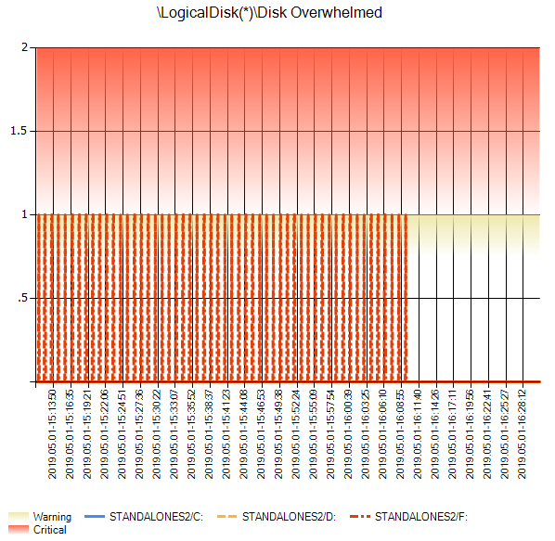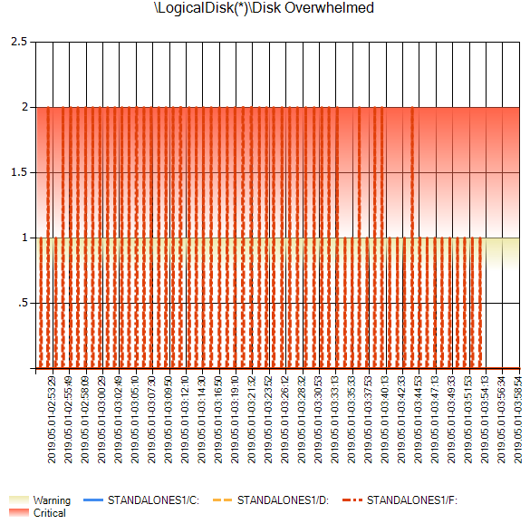

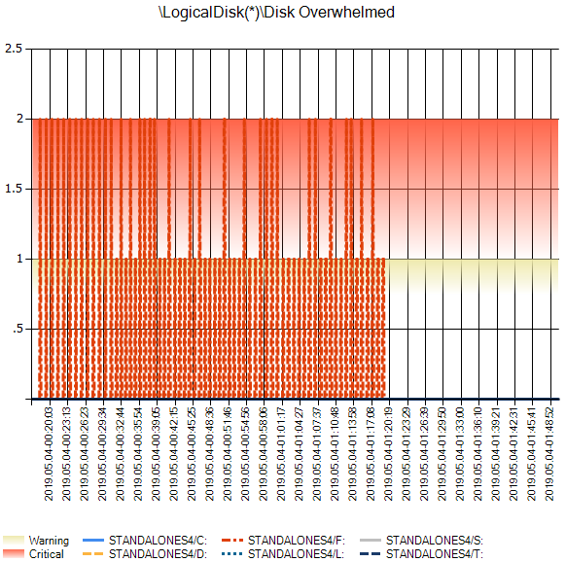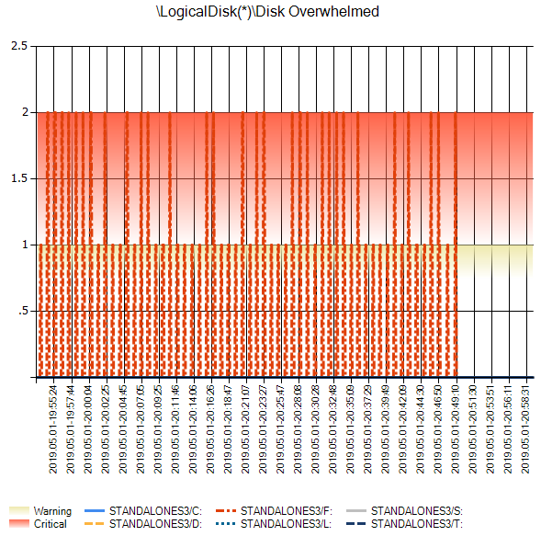

*StandAloneS4*

*StandAloneS2*

*StandAloneS3*

StandAloneS1

### LogicalDisk Avg. Disk sec/Read

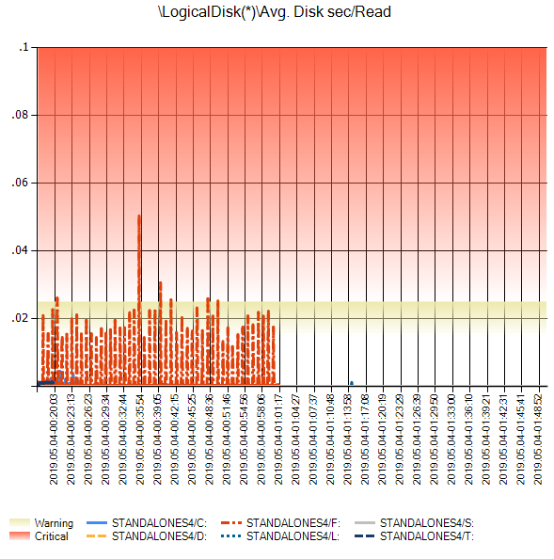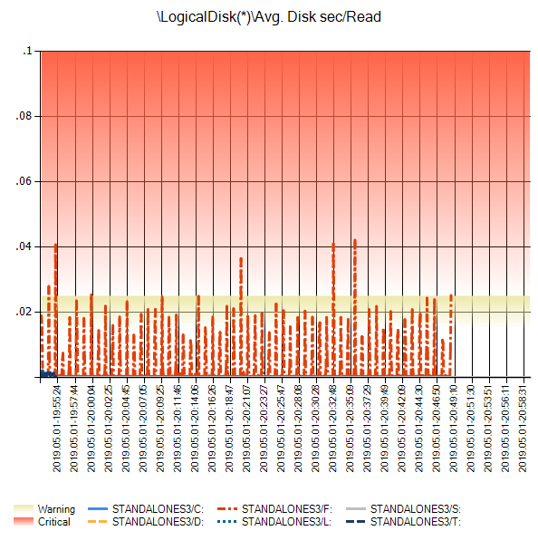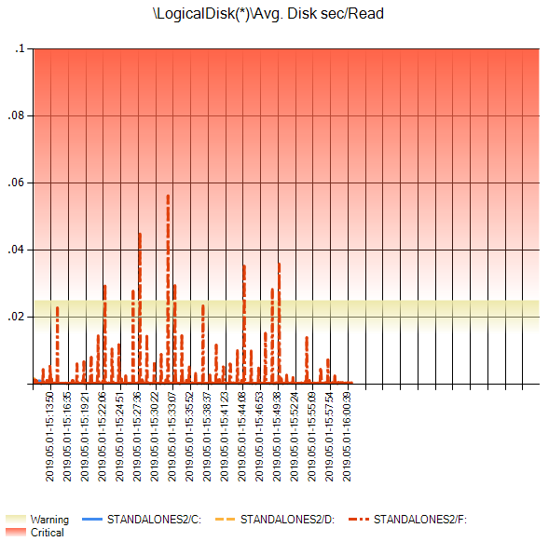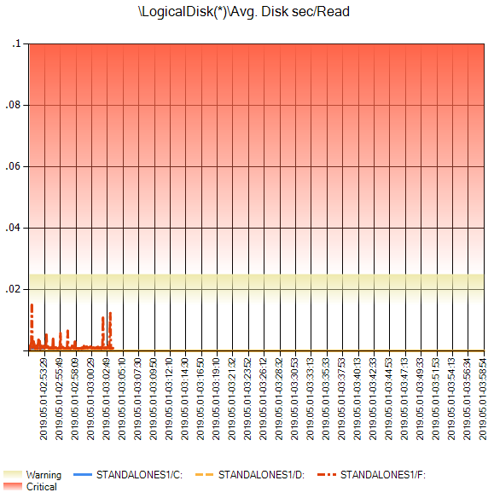

*StandAloneS4*

*StandAloneS3*

*StandAloneS2*

StandAloneS1

### LogicalDisk Avg. Disk sec/Write

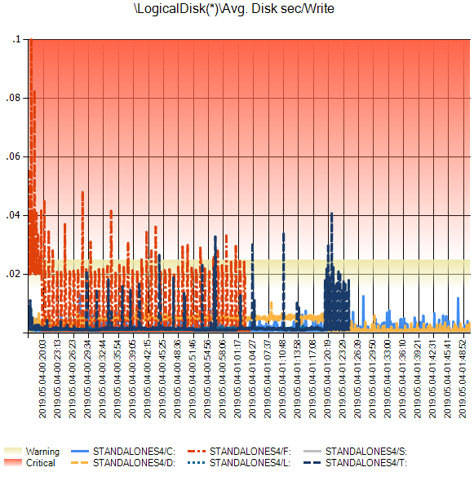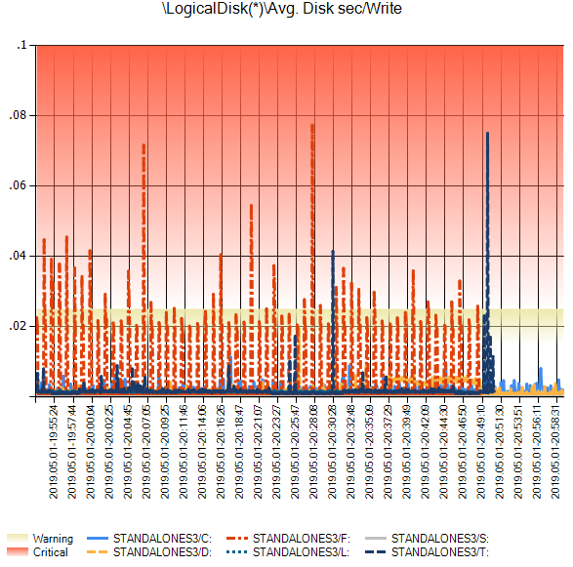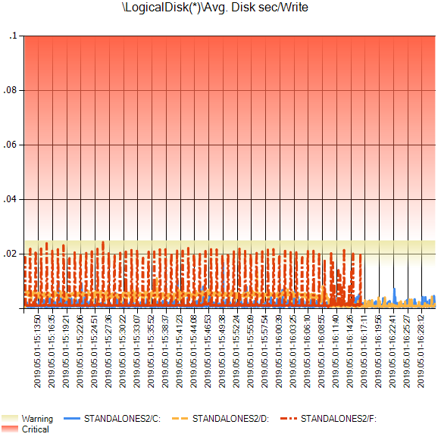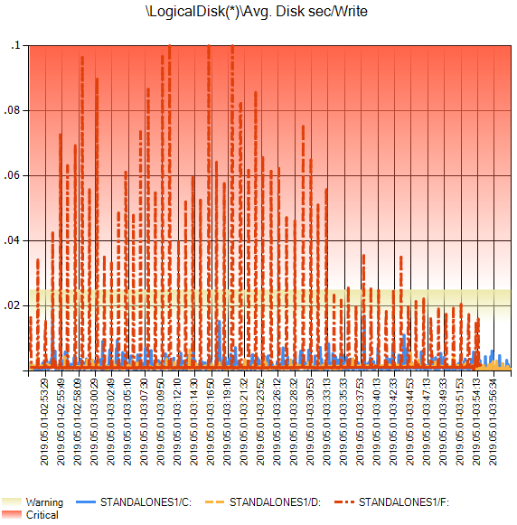

*StandAloneS3*

*StandAloneS4*

*StandAloneS2*

StandAloneS1

### LogicalDisk Disk Transfers/sec

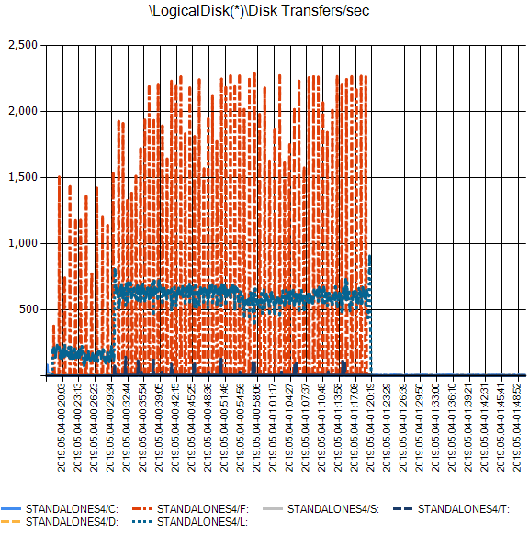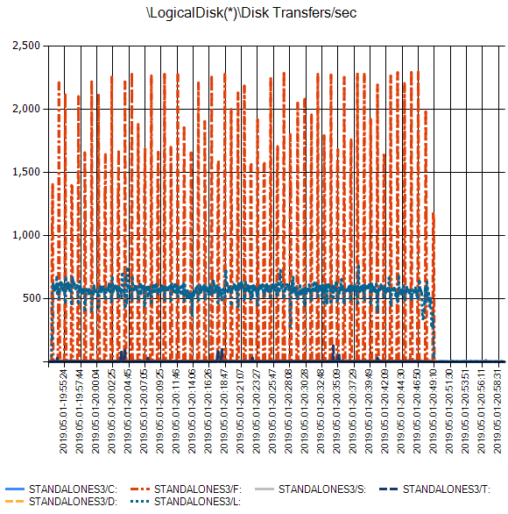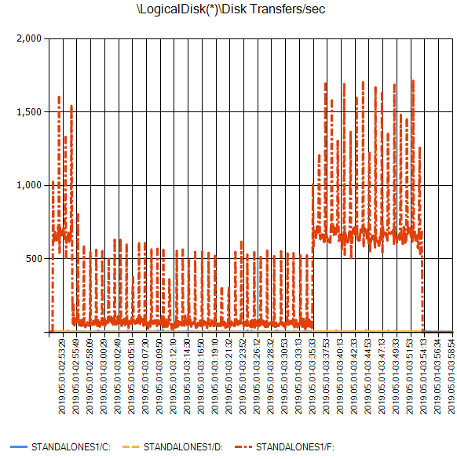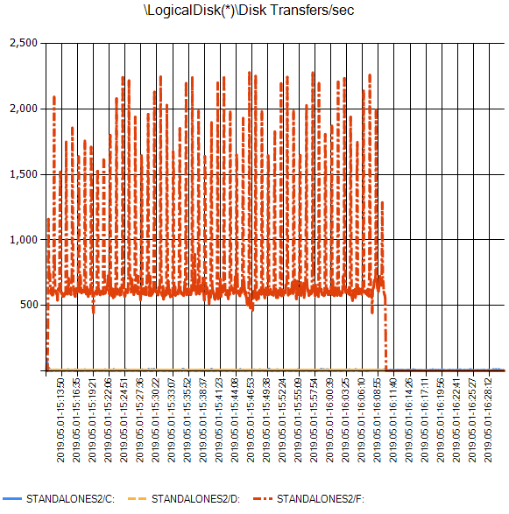

*StandAloneS3*

*StandAloneS4*

StandAloneS1

*StandAloneS2*

### LogicalDisk Disk Reads/sec

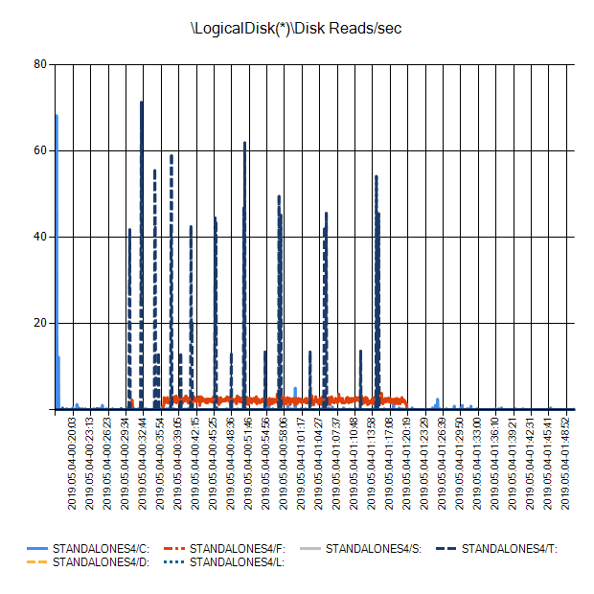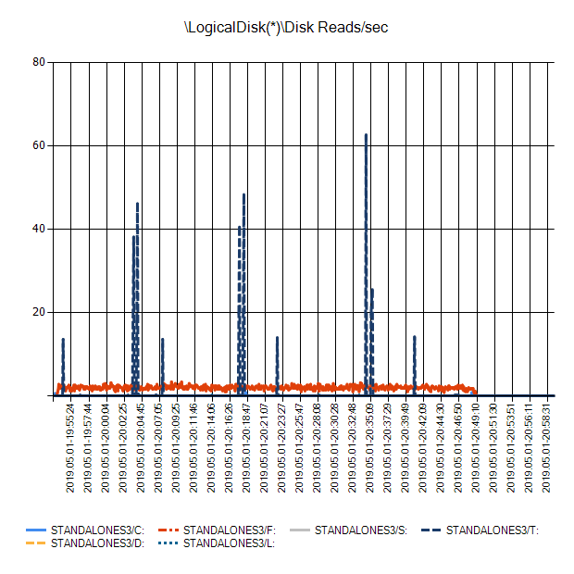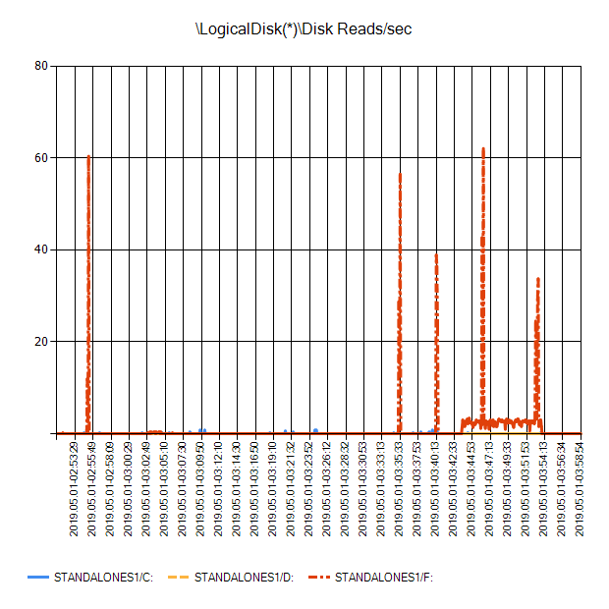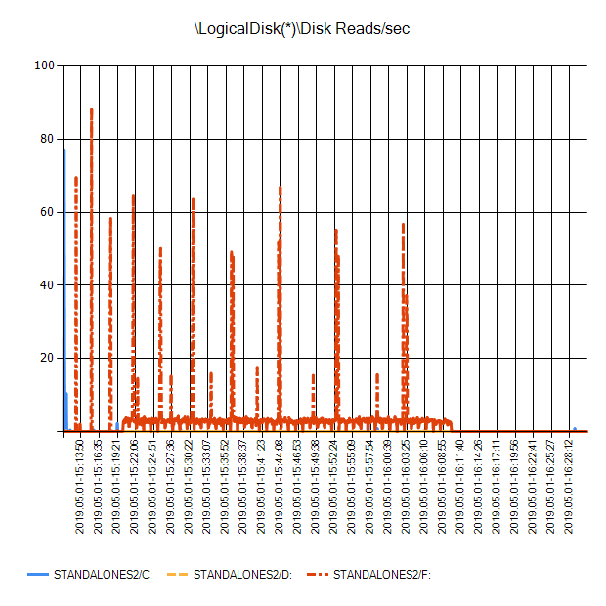

*StandAloneS4*

*StandAloneS3*

*StandAloneS2*

StandAloneS1

### LogicalDisk Disk Write s/sec

*StandAloneS4*

*StandAloneS3*

StandAloneS1

*StandAloneS2*

### LogicalDisk Bytes/Read

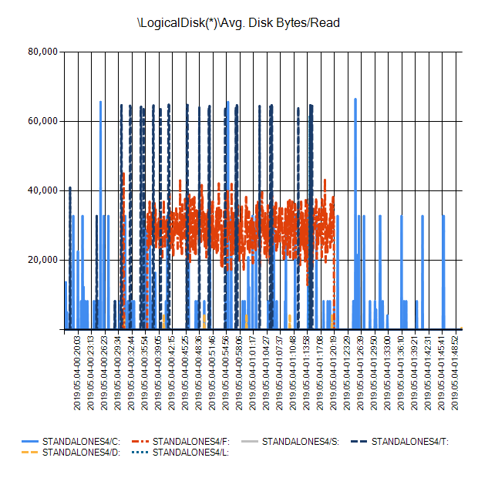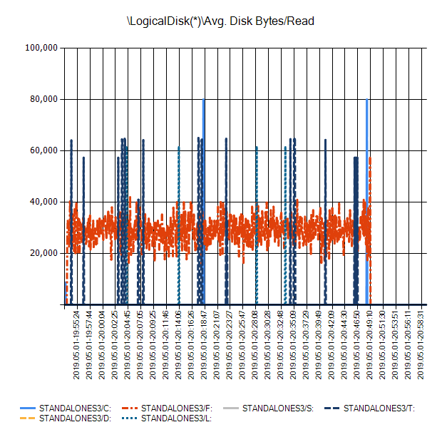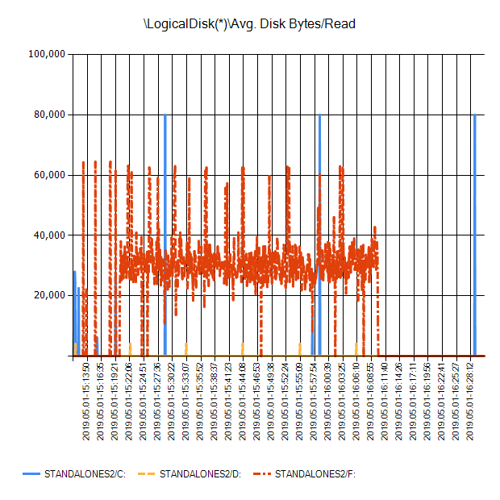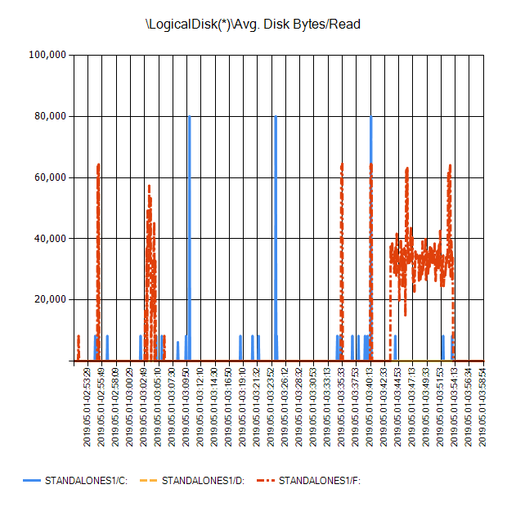

*StandAloneS2*

*StandAloneS3*

StandAloneS1

*StandAloneS4*

### LogicalDisk Bytes/Write

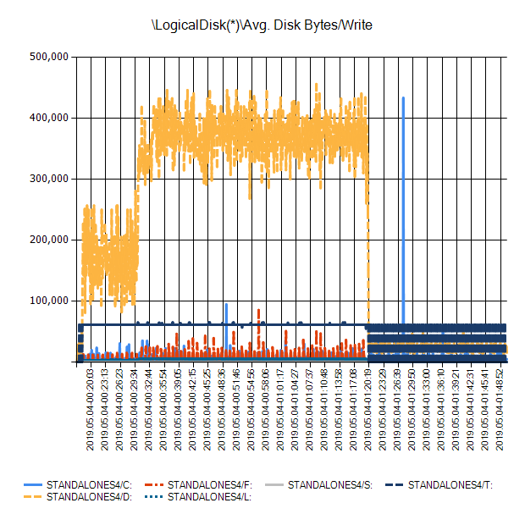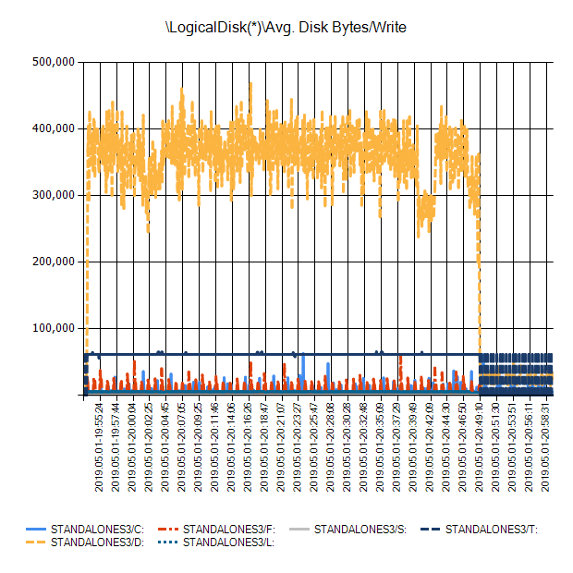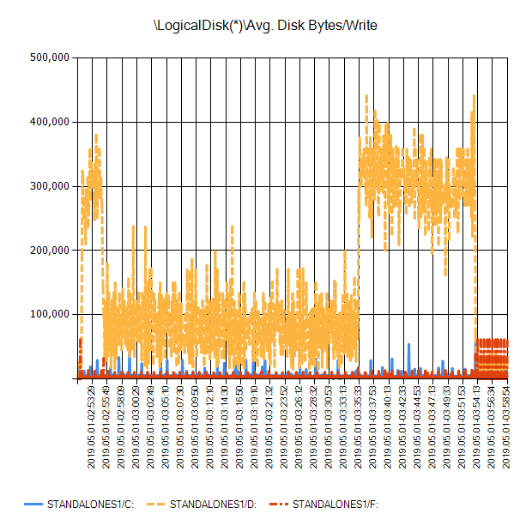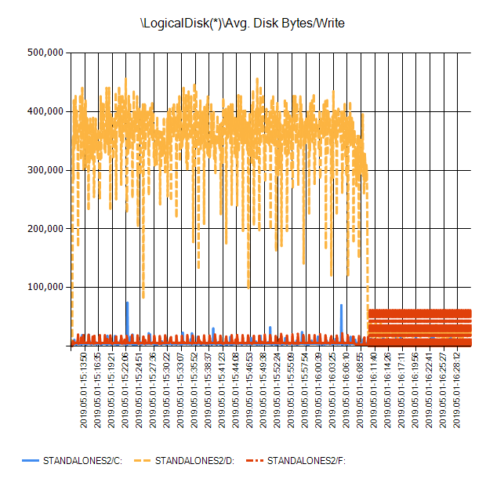

*StandAloneS3*

*StandAloneS4*

*StandAloneS2*

StandAloneS1

### LogicalDisk Avg. Disk Queue Length

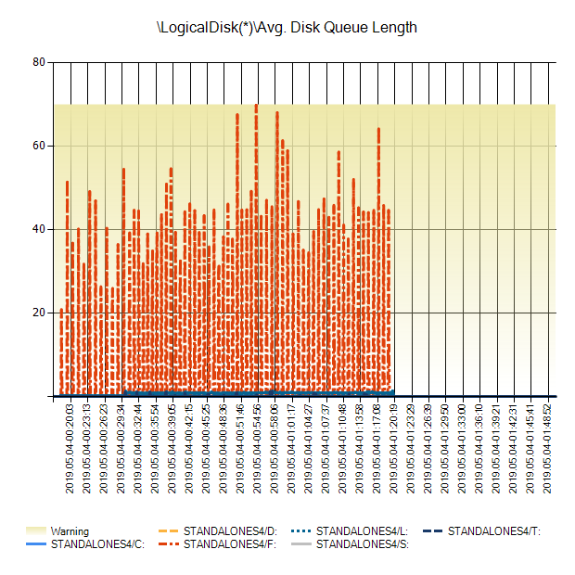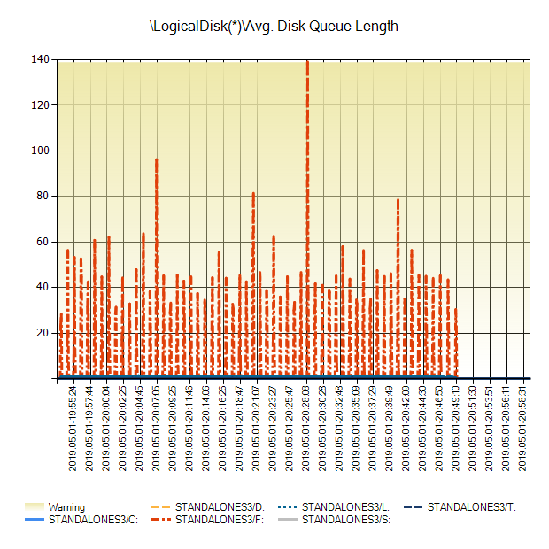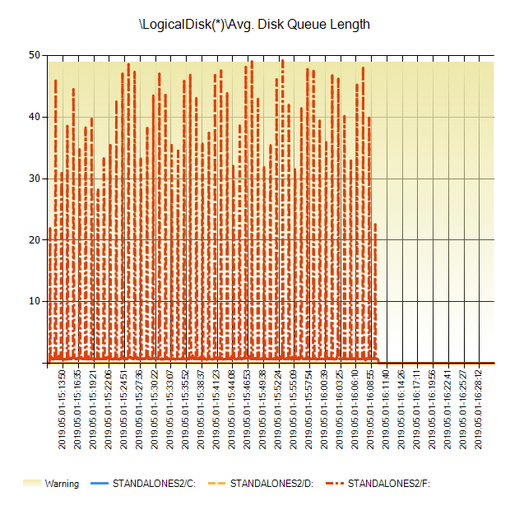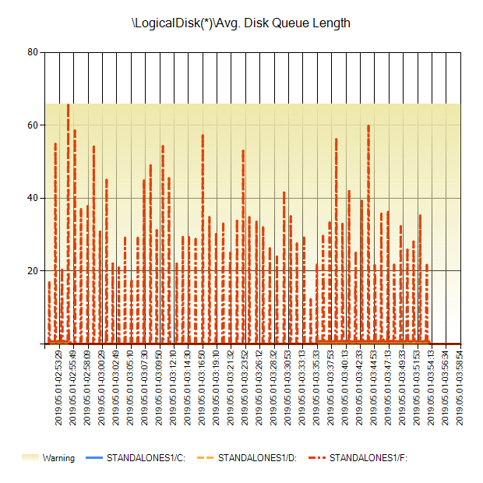

*StandAloneS3*

*StandAloneS4*

StandAloneS1

*StandAloneS2*

### LogicalDisk Current Disk Queue Length

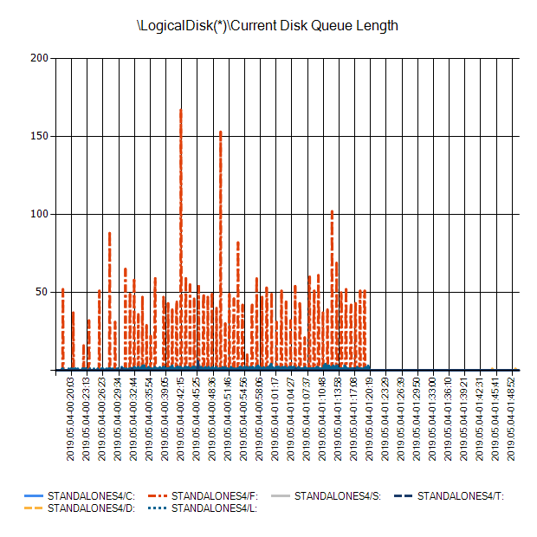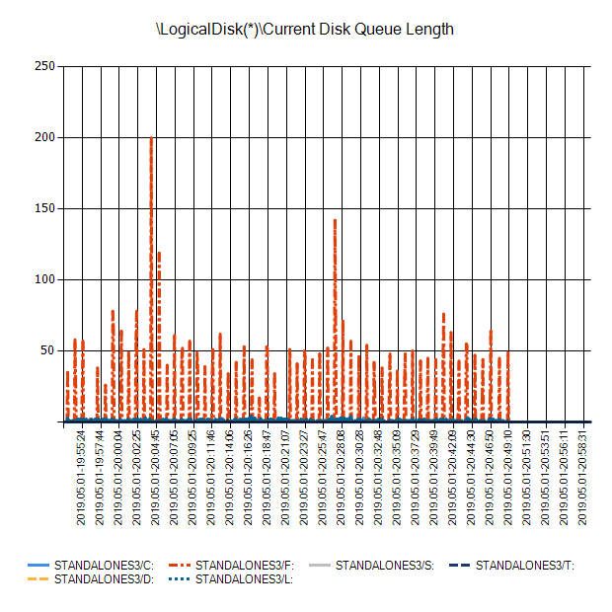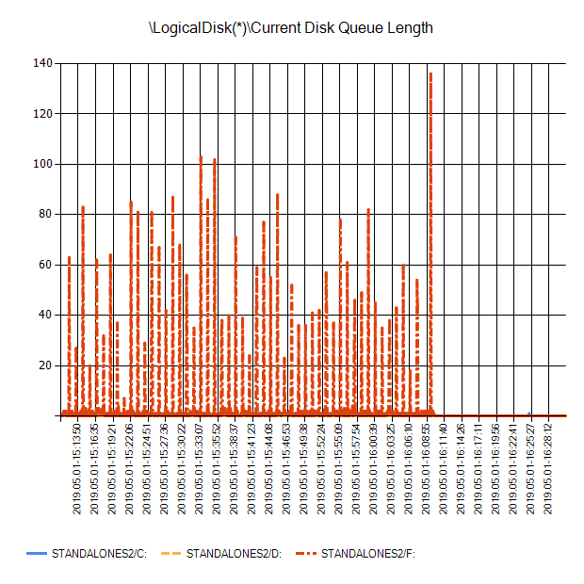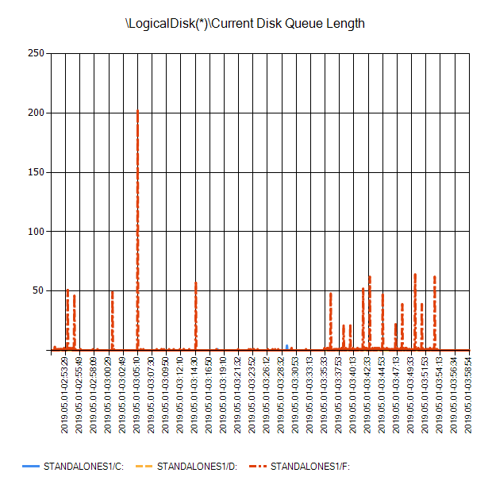

*StandAloneS3*

*StandAloneS4*

*StandAloneS2*

StandAloneS1

### LogicalDisk Disk Bytes/sec

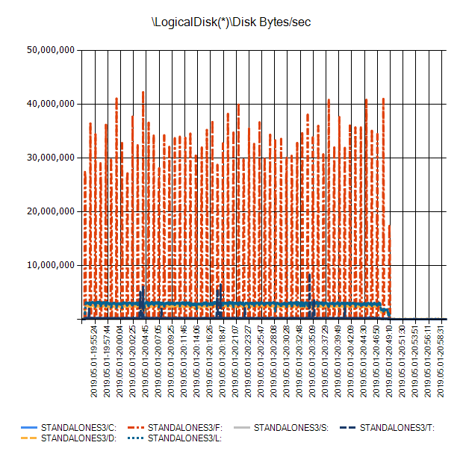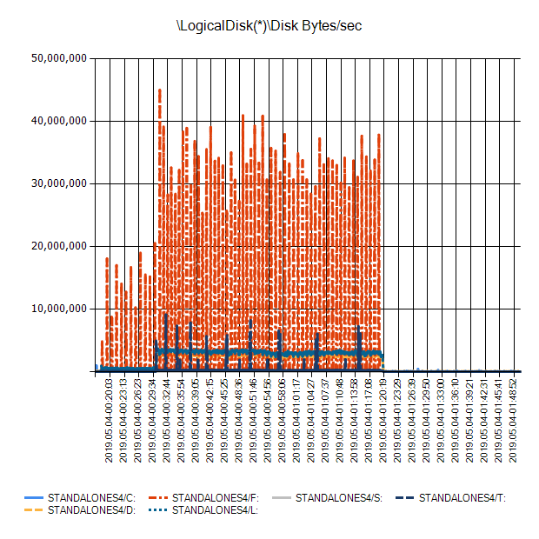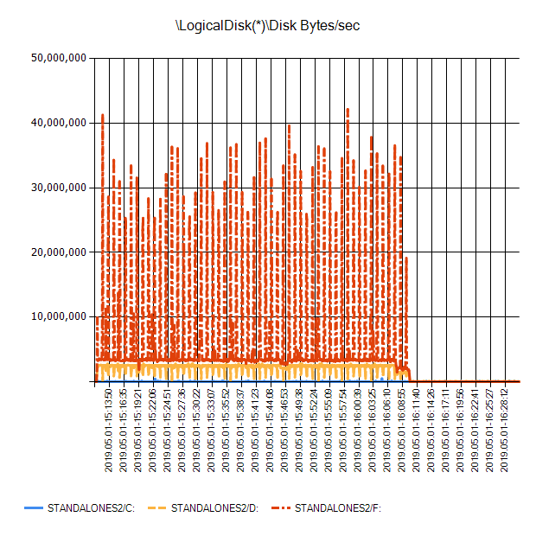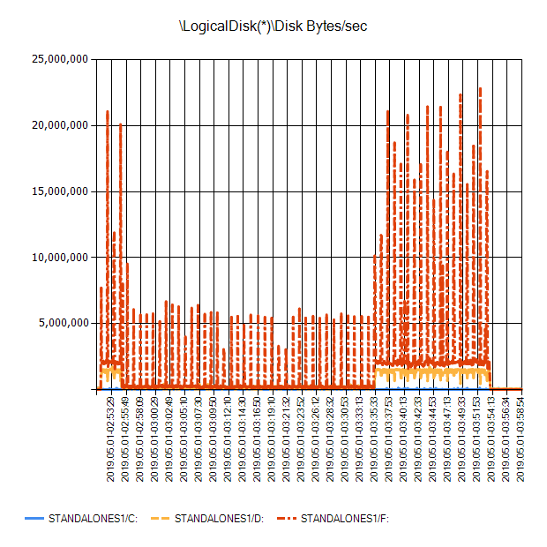

*StandAloneS4*

*StandAloneS3*

StandAloneS1

*StandAloneS2*

### LogicalDisk Avg. Disk sec/Transfer

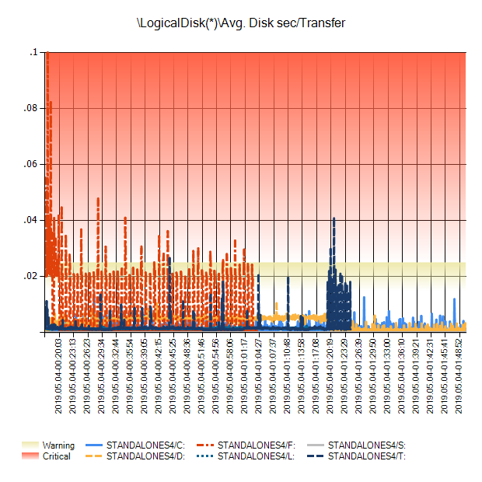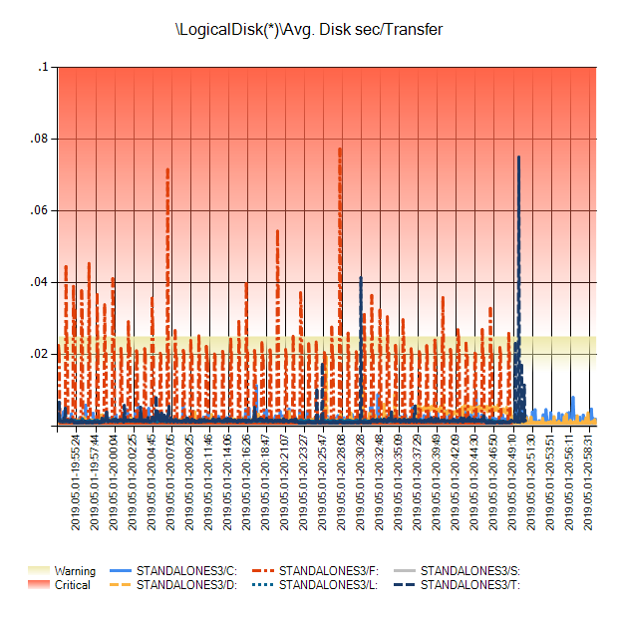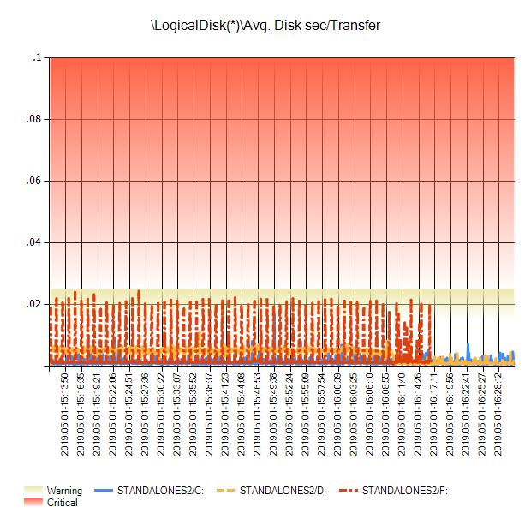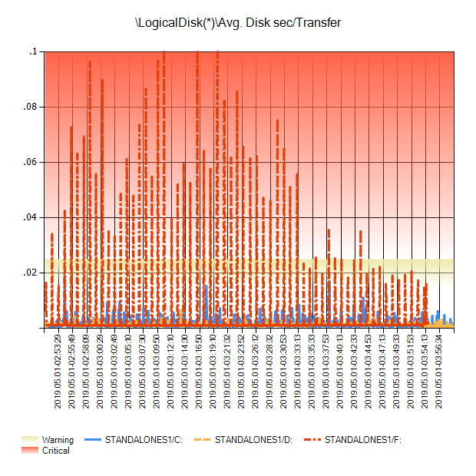

*StandAloneS3*

*StandAloneS4*

*StandAloneS2*

StandAloneS1

### Network Interface Bytes Total/sec

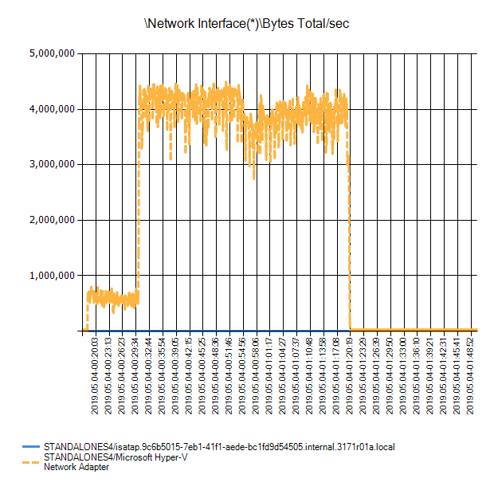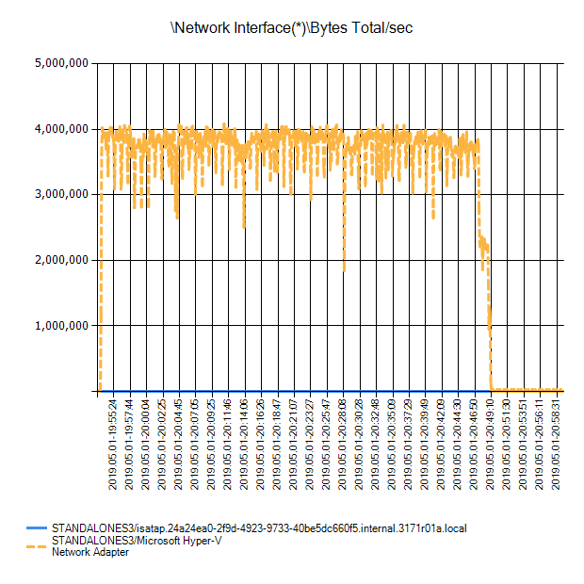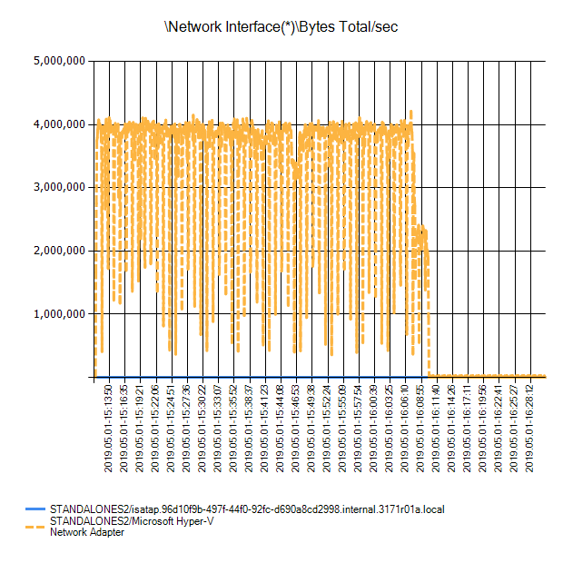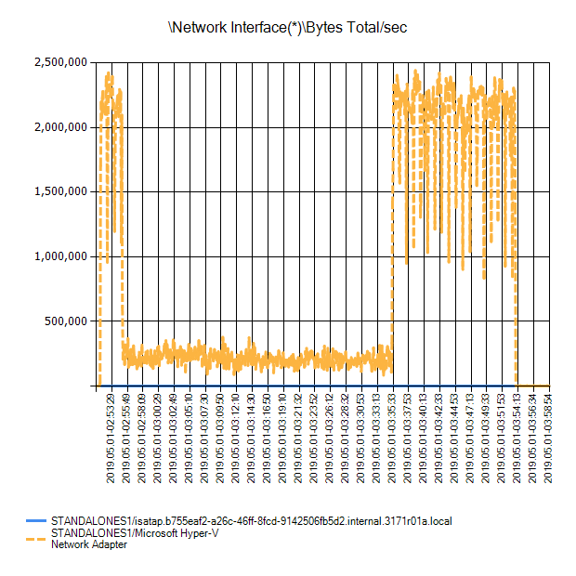

*StandAloneS4*

*StandAloneS3*

*StandAloneS2*

StandAloneS1

### Network Interface Packets Sent/sec

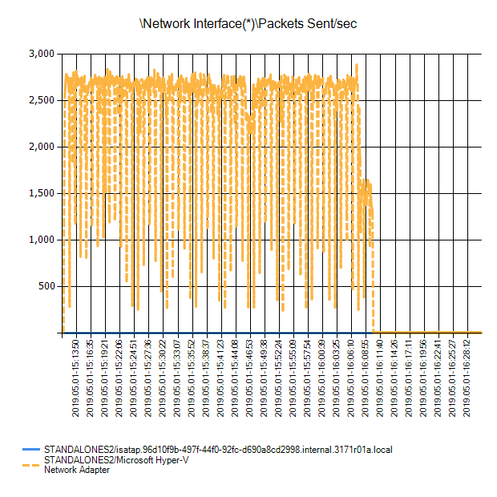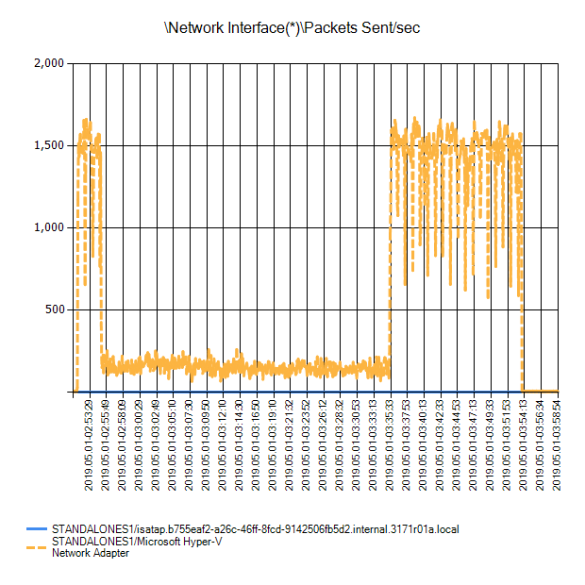

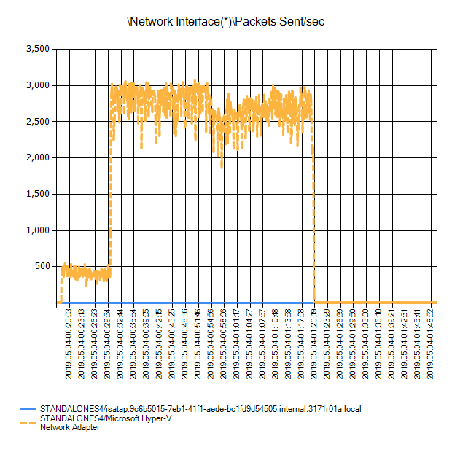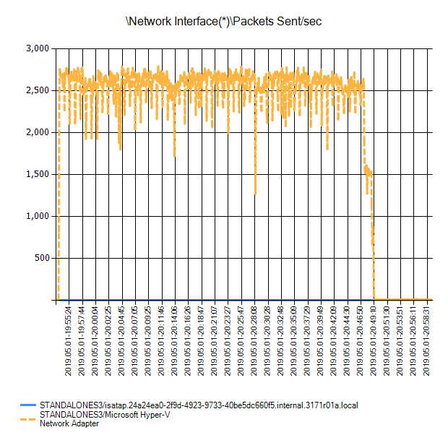

*StandAloneS4*

*StandAloneS3*

StandAloneS1

*StandAloneS2*

### Network Interface Packets Received/sec

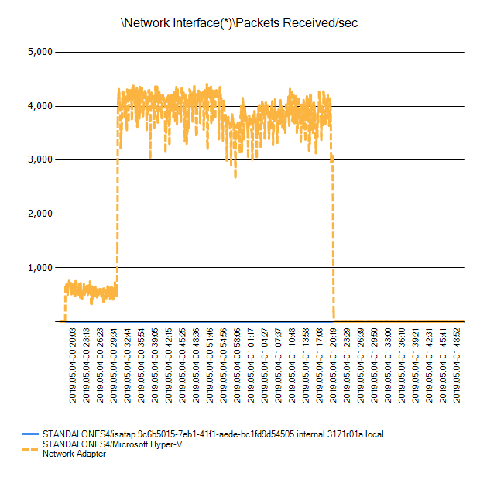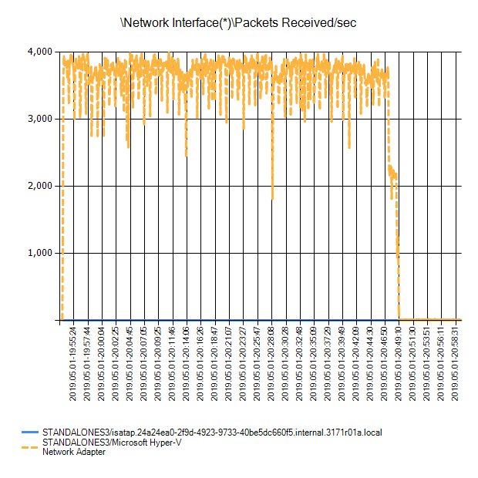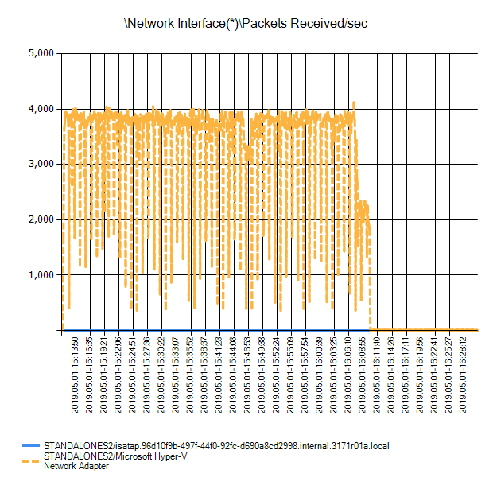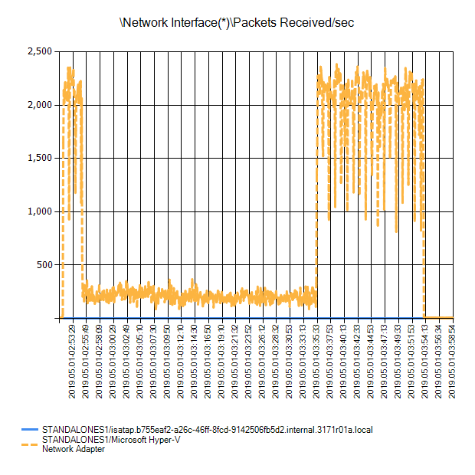

*StandAloneS4*

*StandAloneS3*

StandAloneS1

*StandAloneS2*

### PhysicalDisk Read Latency Analysis

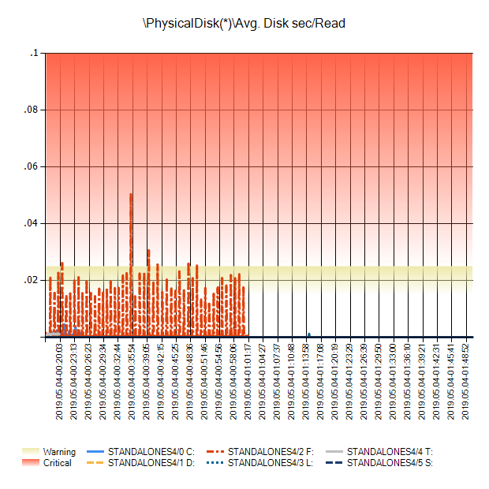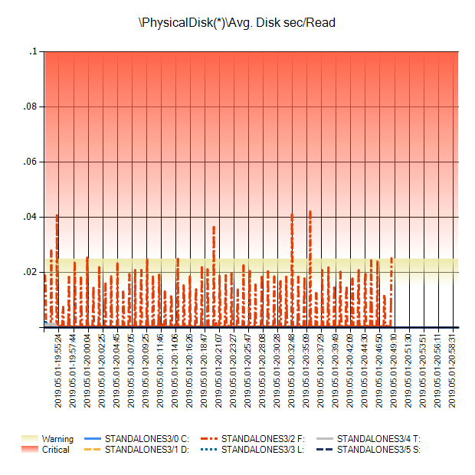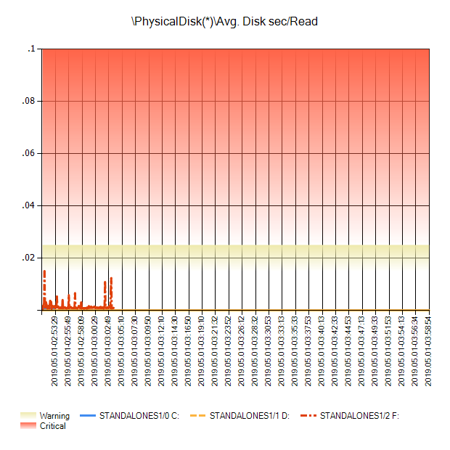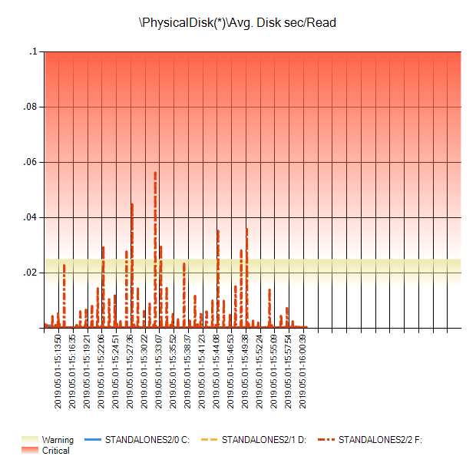

*StandAloneS4*

*StandAloneS3*

StandAloneS1

*StandAloneS2*

### PhysicalDisk Write Latency Analysis

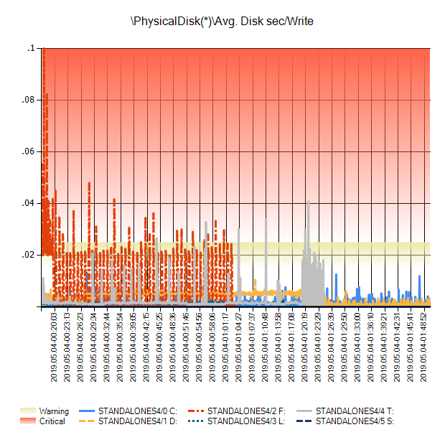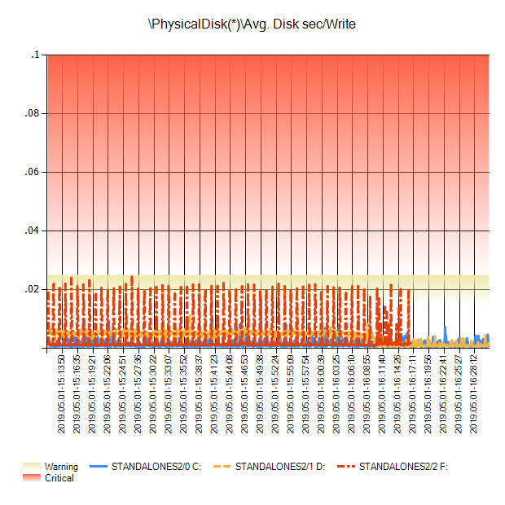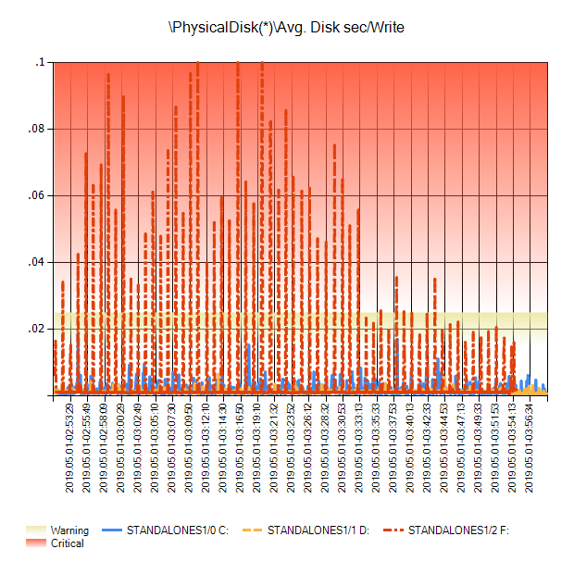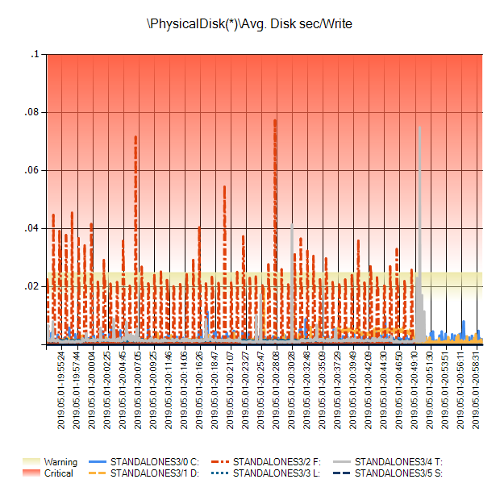

*StandAloneS4*

*StandAloneS3*

*StandAloneS2*

StandAloneS1

### PhysicalDisk Current Disk Queue Length

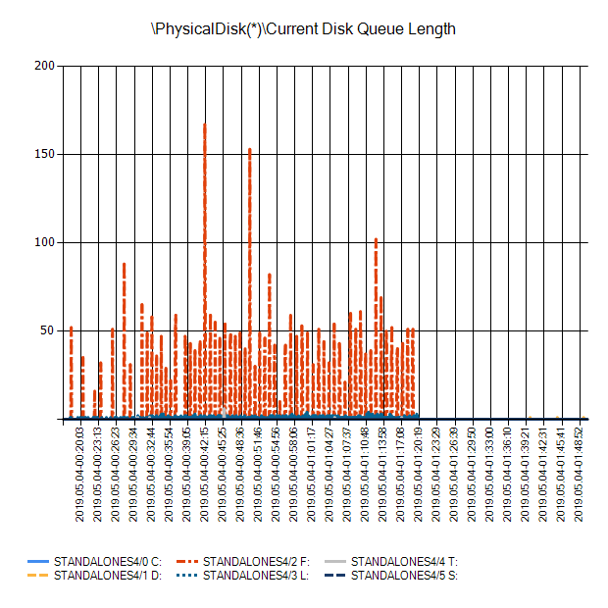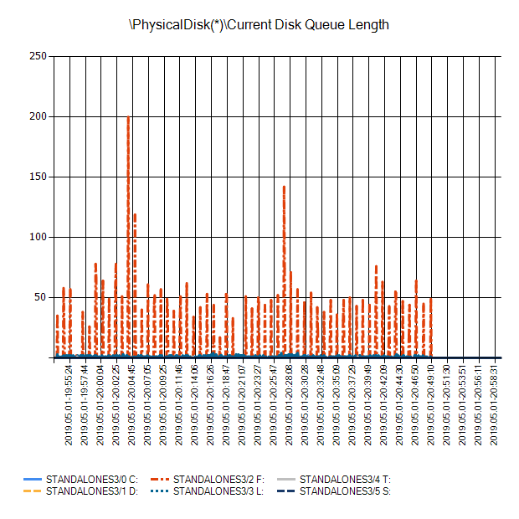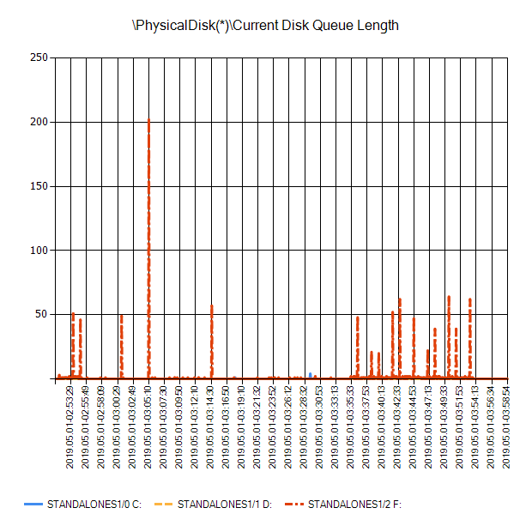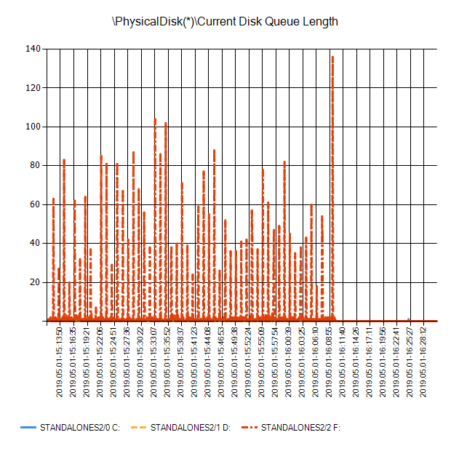

*StandAloneS4*

*StandAloneS3*

*StandAloneS2*

StandAloneS1

### PhysicalDisk Avg. Disk Queue Length

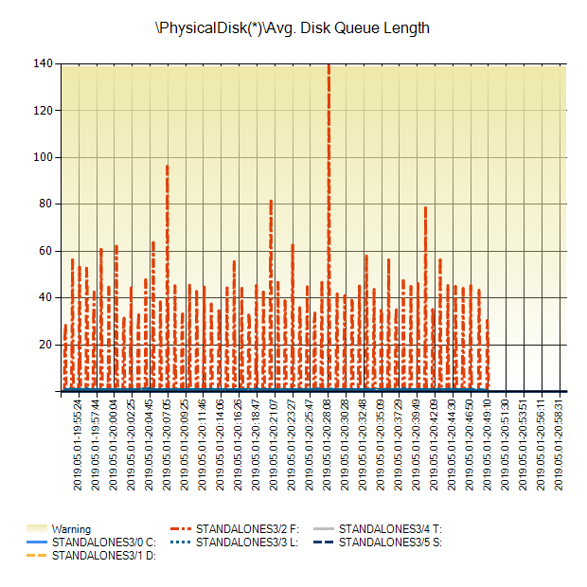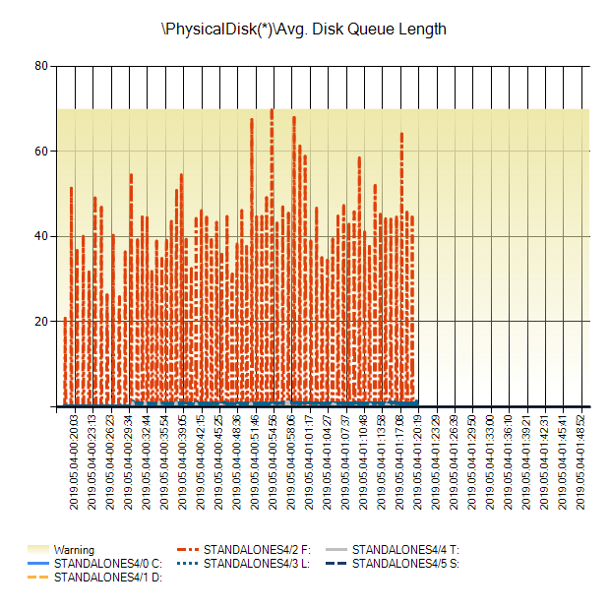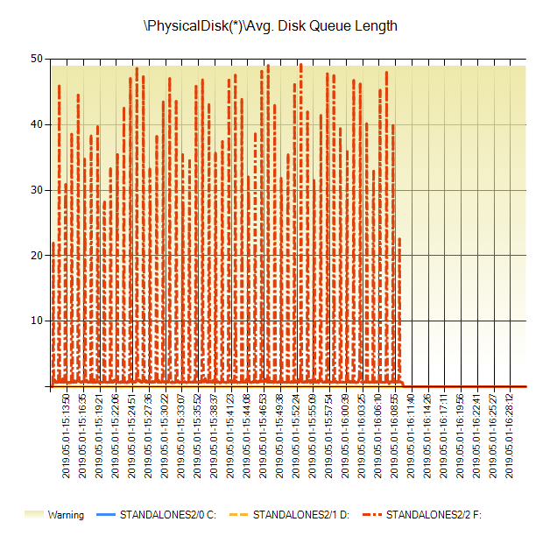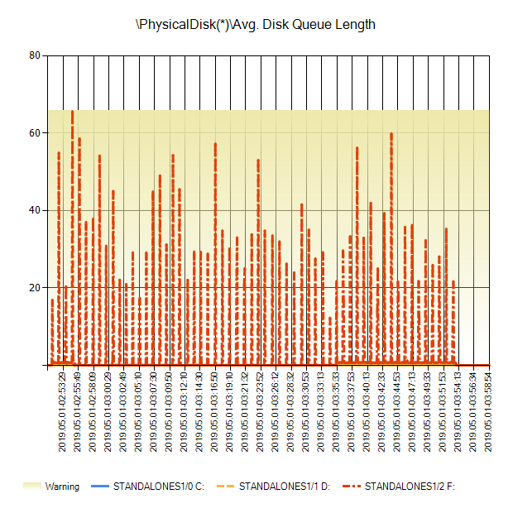

*StandAloneS4*

*StandAloneS3*

*StandAloneS2*

StandAloneS1

### PhysicalDisk Disk Bytes/sec

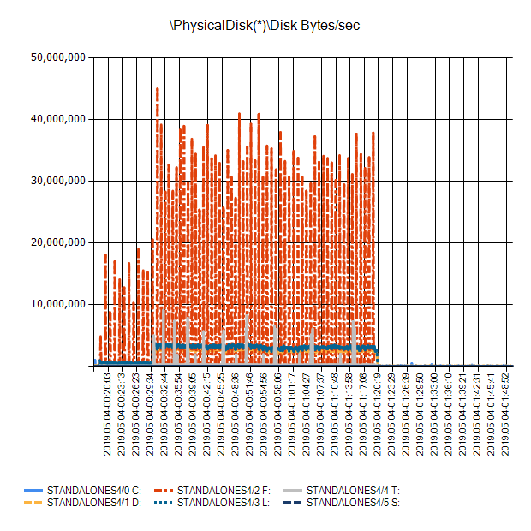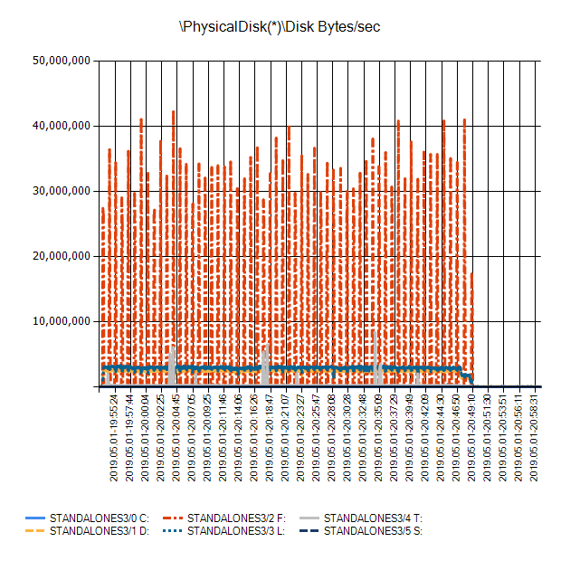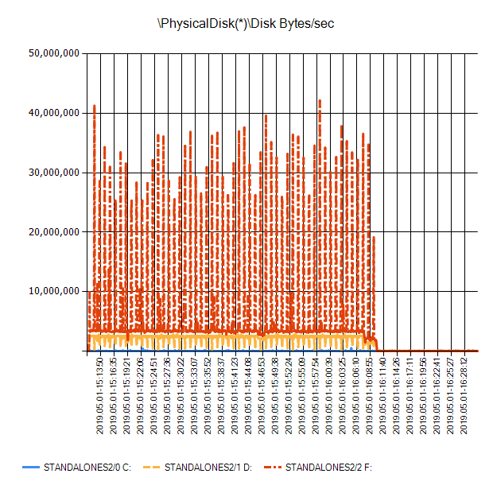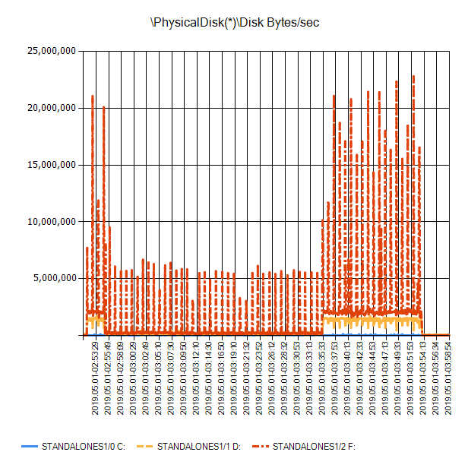

*StandAloneS3*

*StandAloneS4*

*StandAloneS2*

StandAloneS1

### SQLServer:Access Methods Forwarded Records/sec: SQL Statistics\Batch Requests/sec

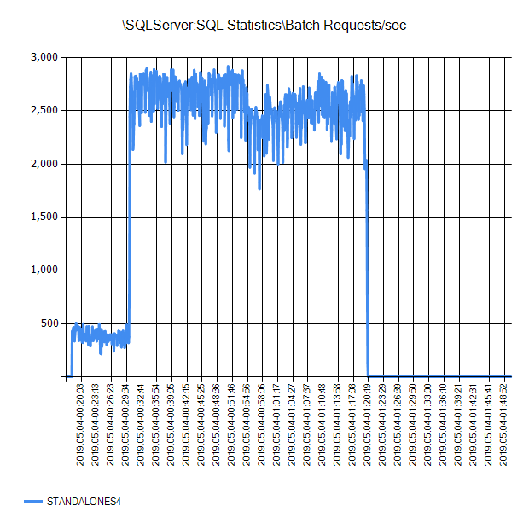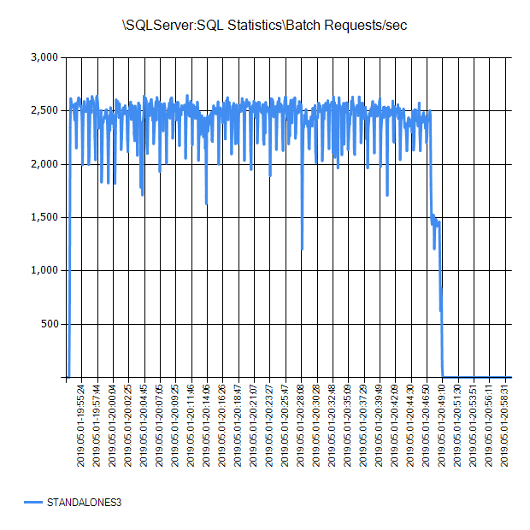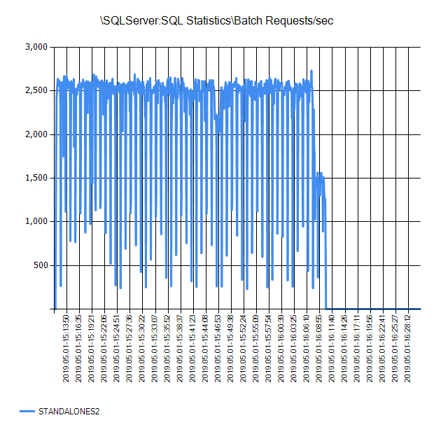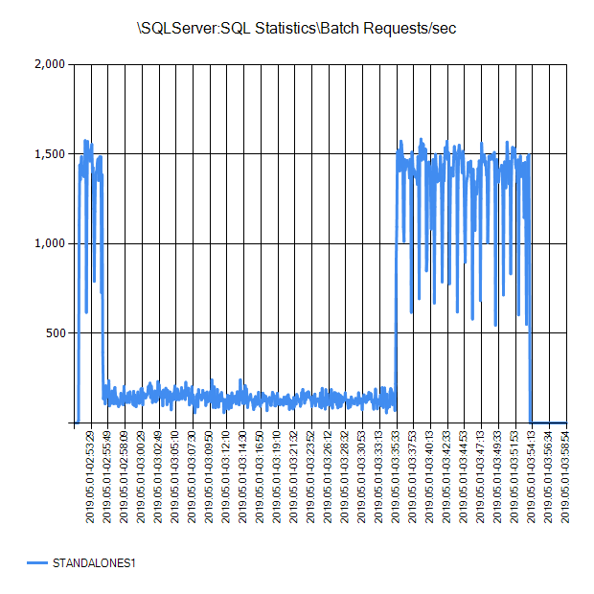

*StandAloneS3*

*StandAloneS4*

*StandAloneS2*

StandAloneS1

### SQLServer:Access Methods FreeSpace Scans/sec: Access Methods\FreeSpace Scans/sec

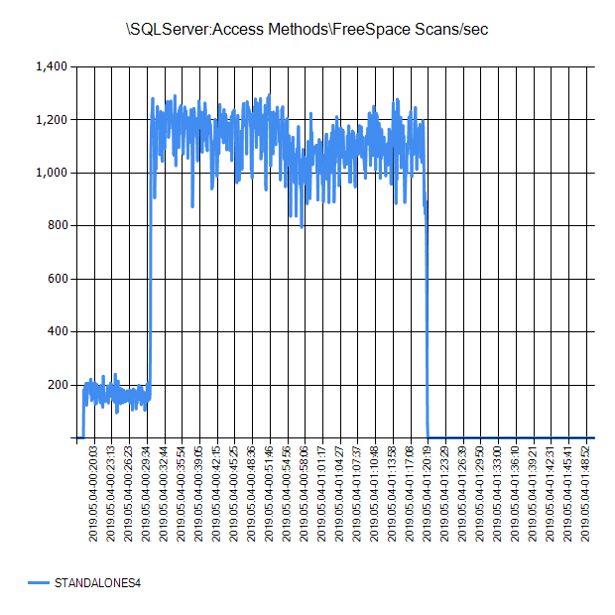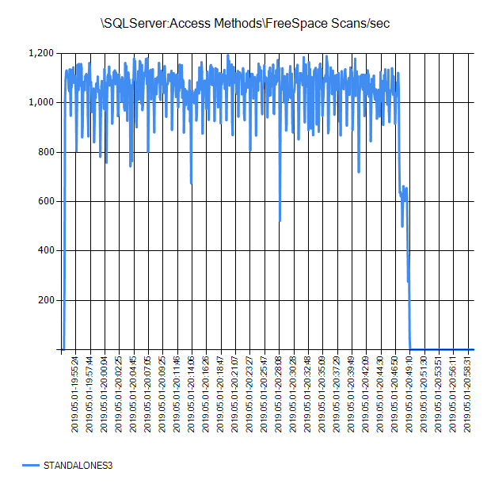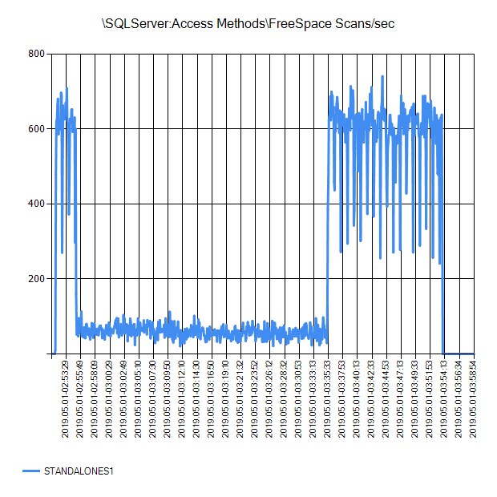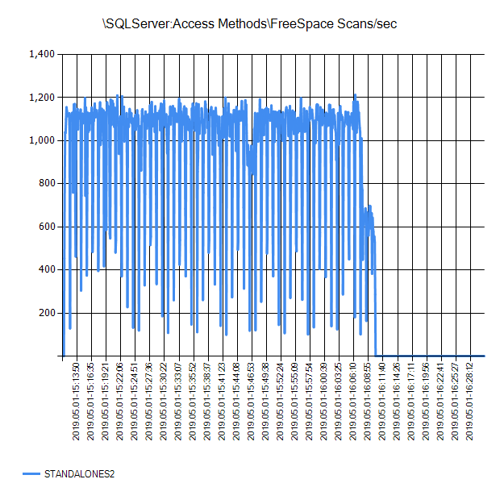

*StandAloneS3*

*StandAloneS4*

*StandAloneS2*

StandAloneS1

### SQLServer:Access Methods FreeSpace Scans/sec: SQL Statistics\Batch Requests/sec



*StandAloneS4*

*StandAloneS3*

*StandAloneS2*

StandAloneS1

### SQLServer:Access Methods Full Scans/sec

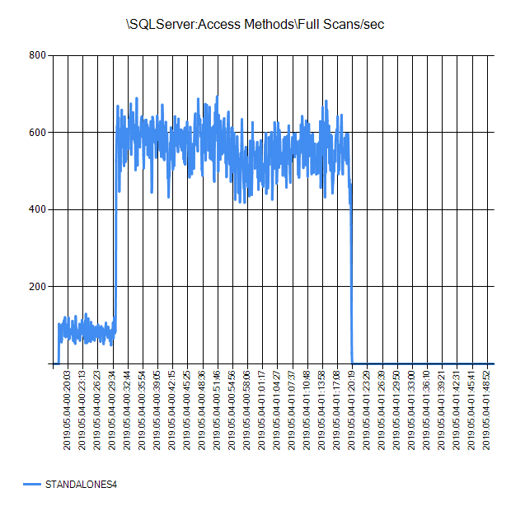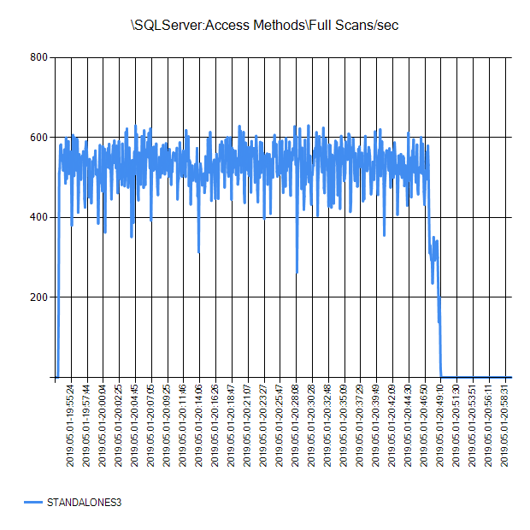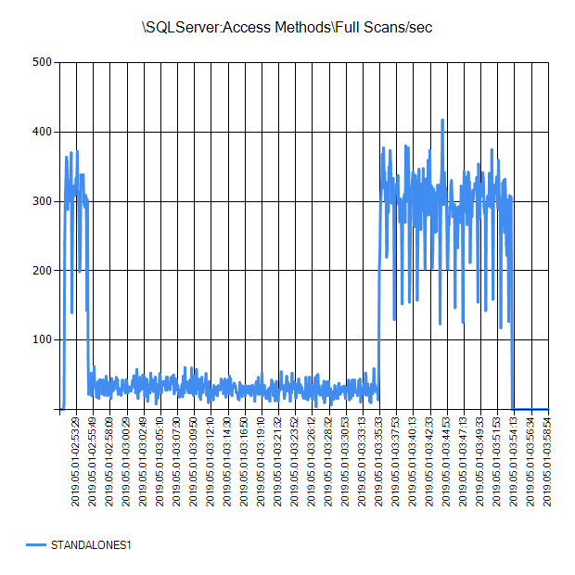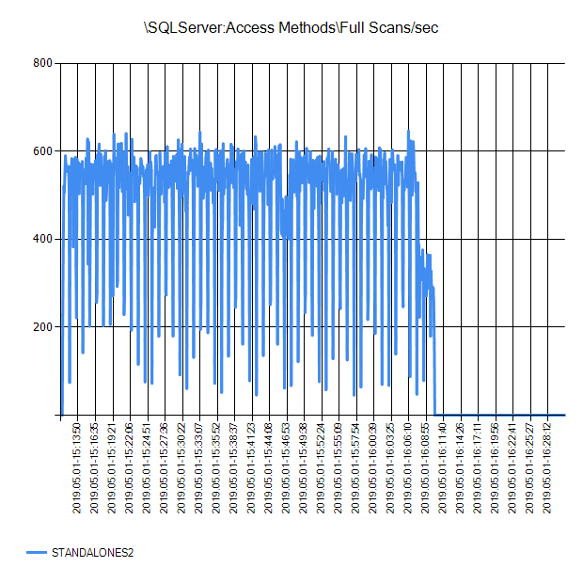

*StandAloneS3*

*StandAloneS4*

StandAloneS1

*StandAloneS2*

### SQLServer:Access Methods Page Splits/sec

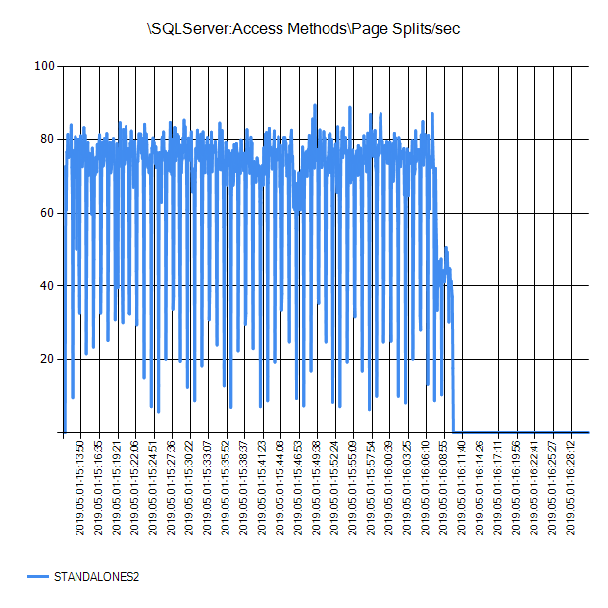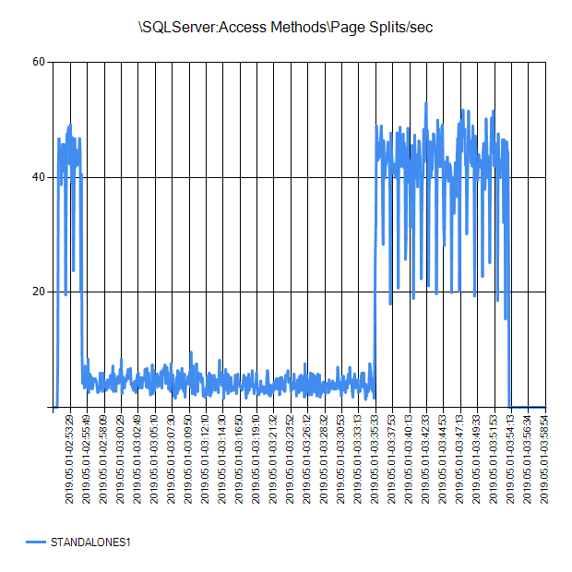

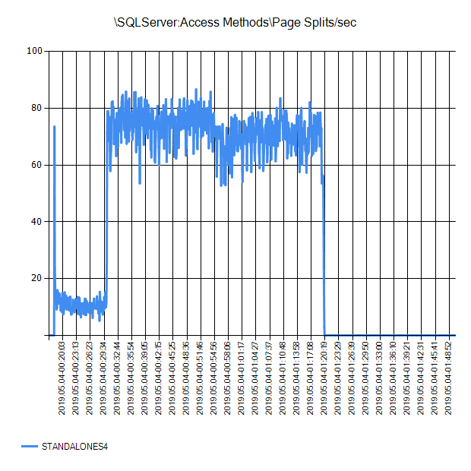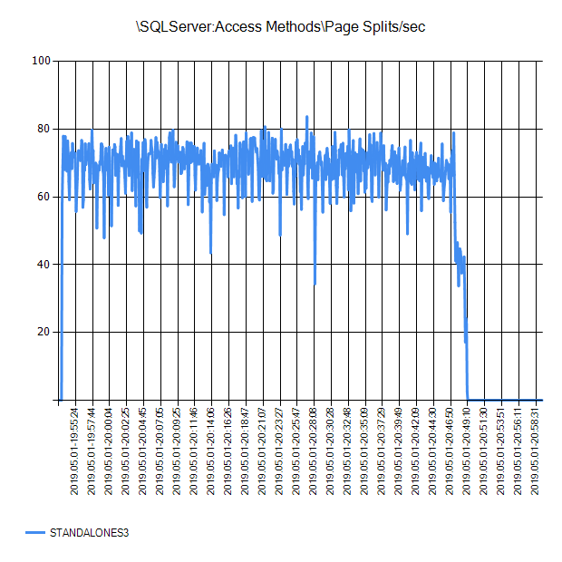

*StandAloneS3*

*StandAloneS4*

*StandAloneS2*

StandAloneS1

### SQLServer:Access Methods Page Splits/sec – Batch Request/sec



*StandAloneS4*

*StandAloneS3*

*StandAloneS2*

StandAloneS1

### SQLServer:Access Methods Workfiles Created/sec

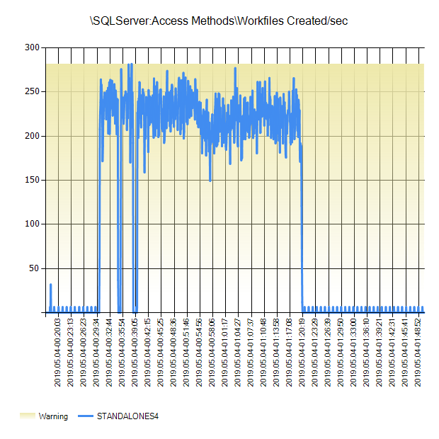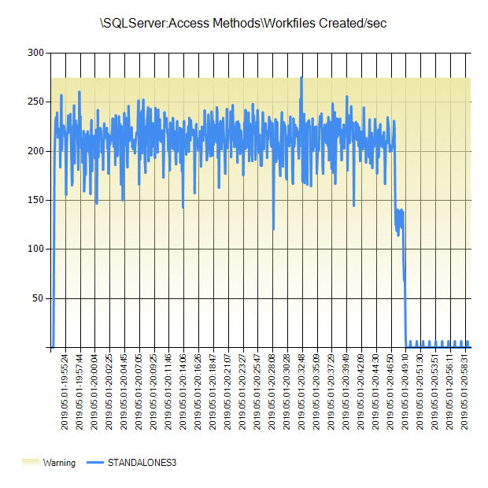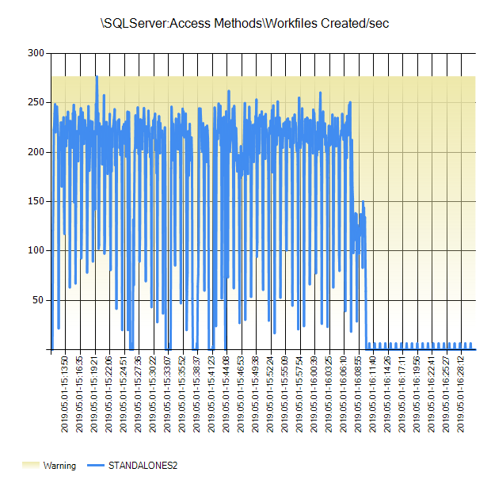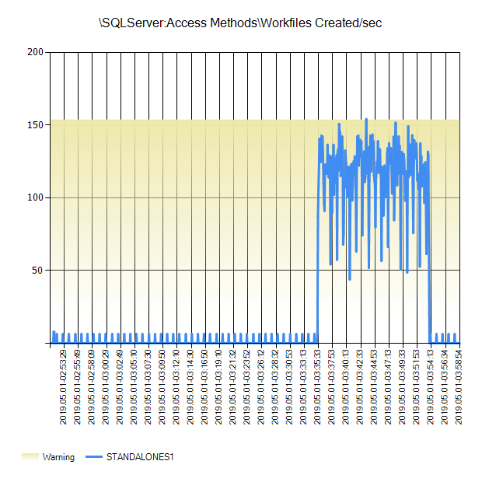

*StandAloneS4*

*StandAloneS3*

*StandAloneS2*

StandAloneS1

### SQLServer:Access Methods Workfiles Created/sec -Batch Requests/sec



*StandAloneS3*

*StandAloneS4*

*StandAloneS2*

StandAloneS1

### SQLServer:Access Methods Worktables Created/sec

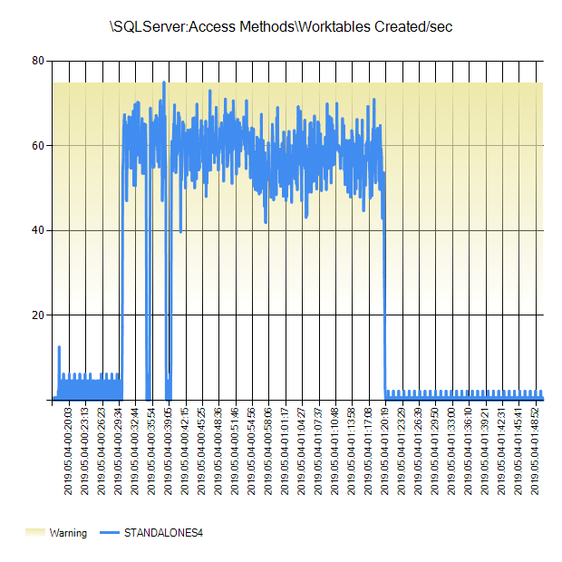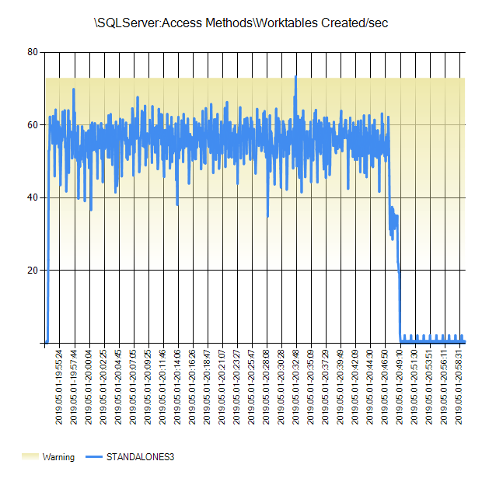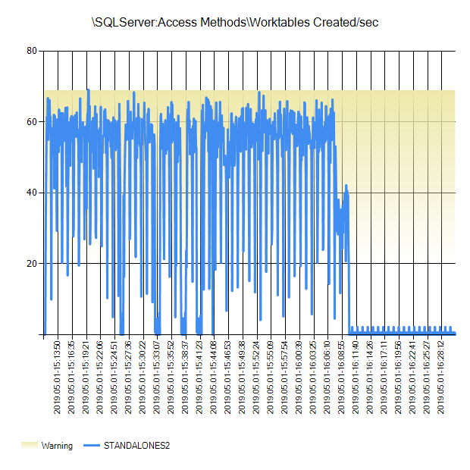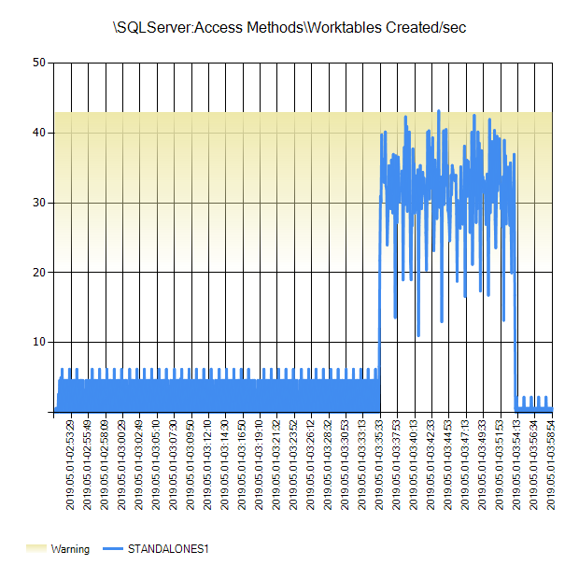

*StandAloneS4*

*StandAloneS3*

StandAloneS1

*StandAloneS2*

### SQLServer:Access Methods\Full Scan/sec



*StandAloneS4*

*StandAloneS3*

*StandAloneS2*

StandAloneS1

### SQLServer:Access Methods\Index Searches/sec

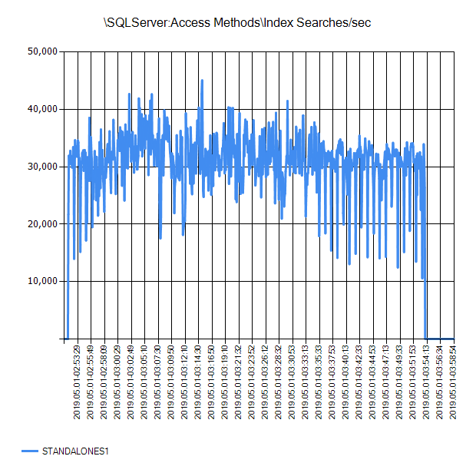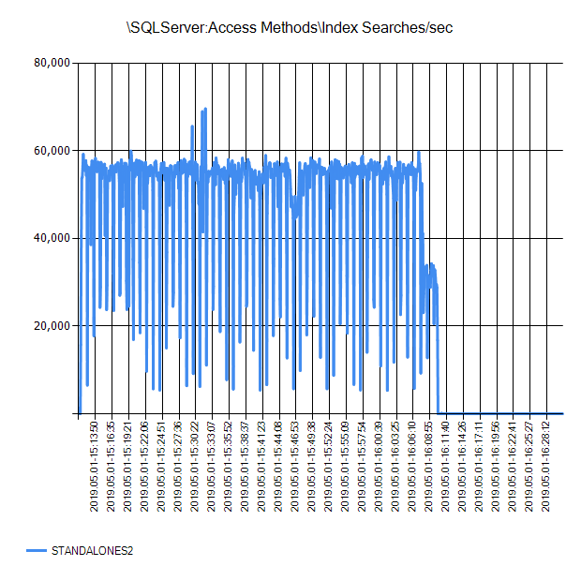

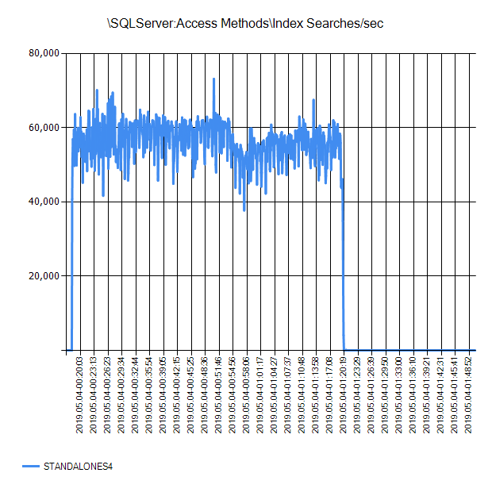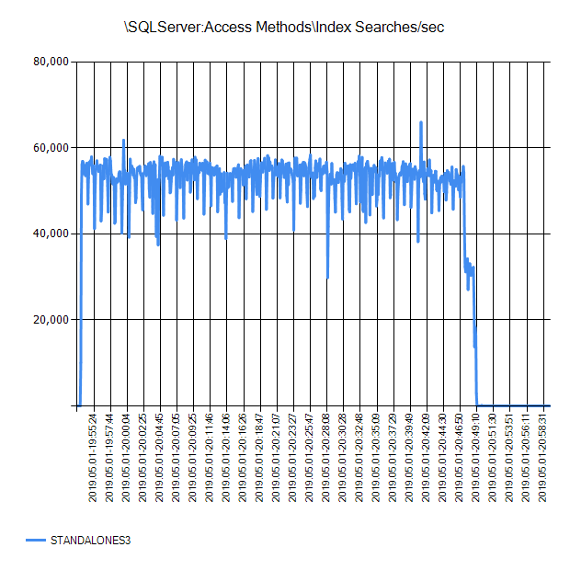

*StandAloneS4*

*StandAloneS3*

*StandAloneS2*

StandAloneS1

### SQLServer:Buffer Manager\Checkpoint pages/sec

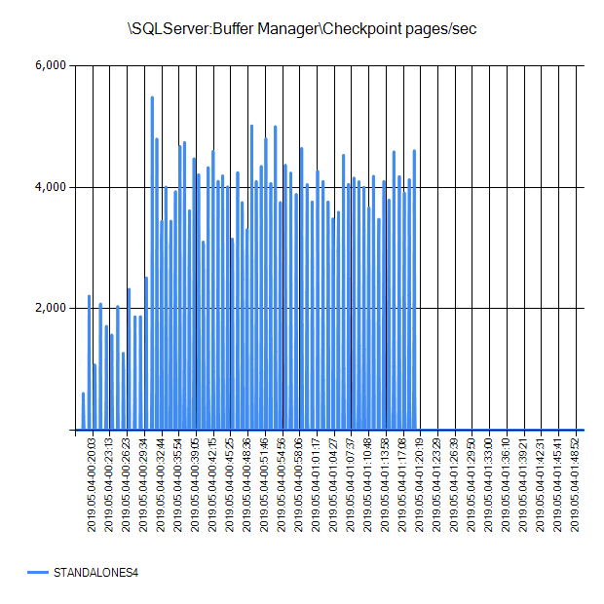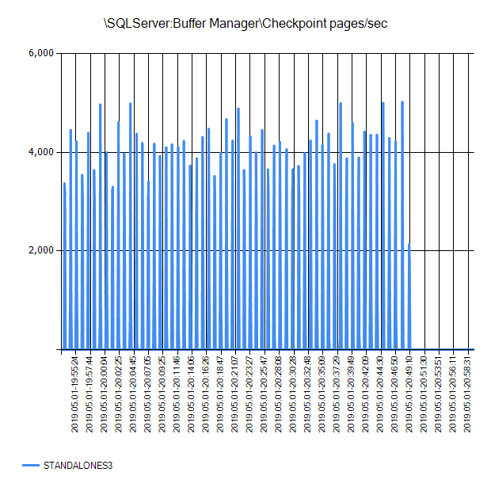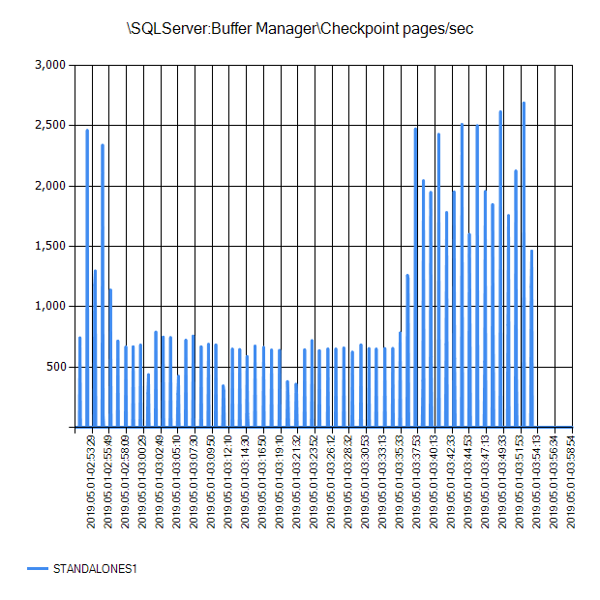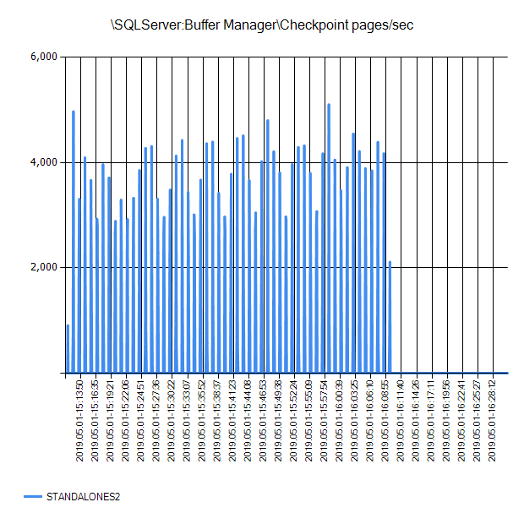

*StandAloneS4*

*StandAloneS3*

StandAloneS1

*StandAloneS2*

### SQLServer:Buffer Lazy write/sec





*StandAloneS4*

*StandAloneS3*

*StandAloneS2*

StandAloneS1

### SQLServer:Buffer Manager Page lookups/sec

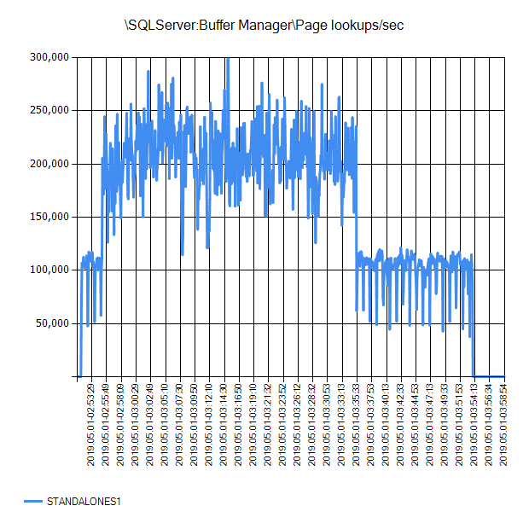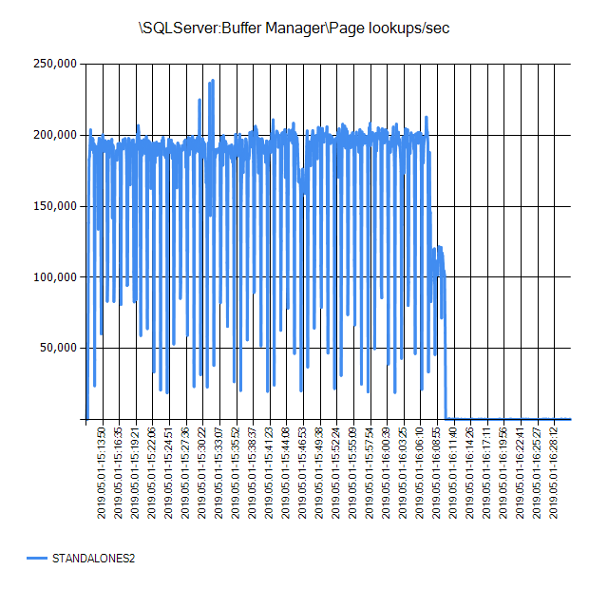

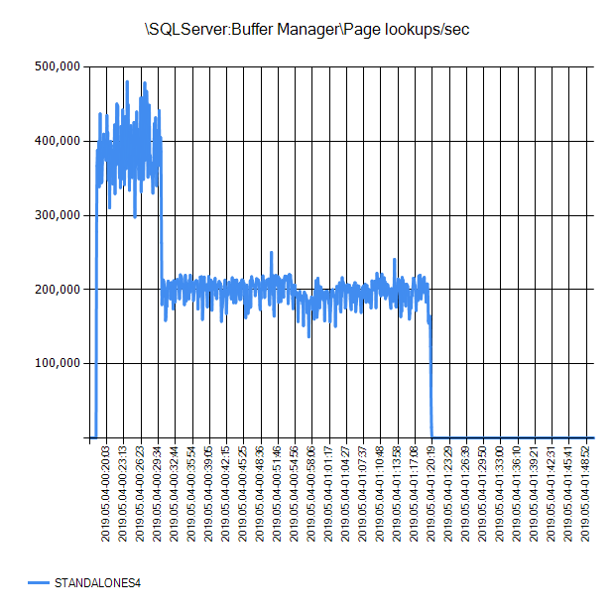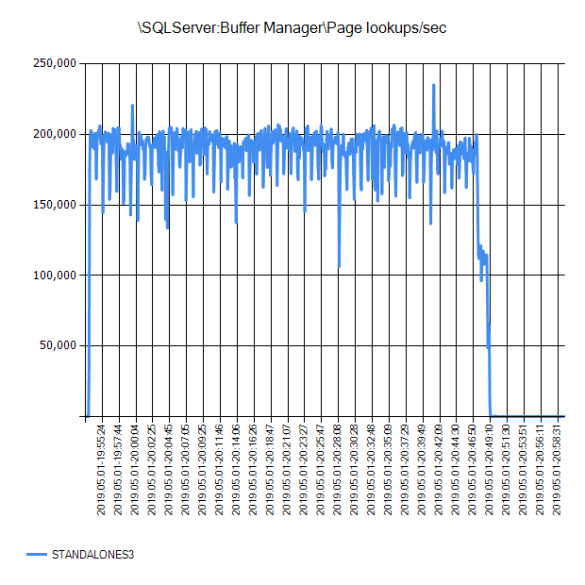

*StandAloneS4*

*StandAloneS3*

*StandAloneS2*

StandAloneS1

### SQLServer:Databases Data File Size (KB)

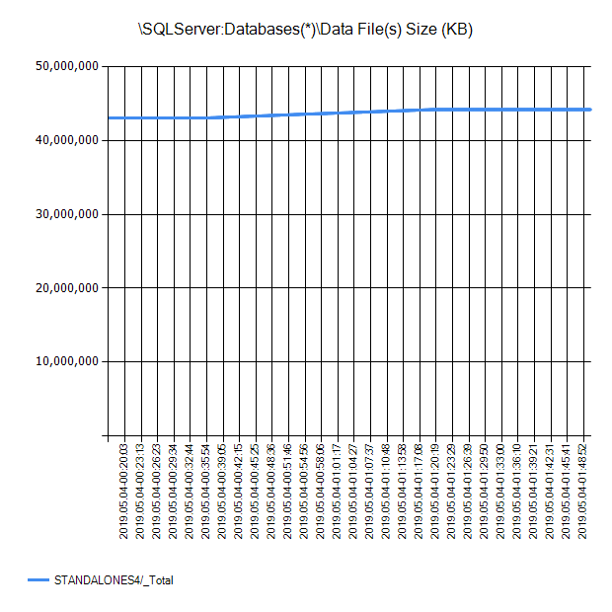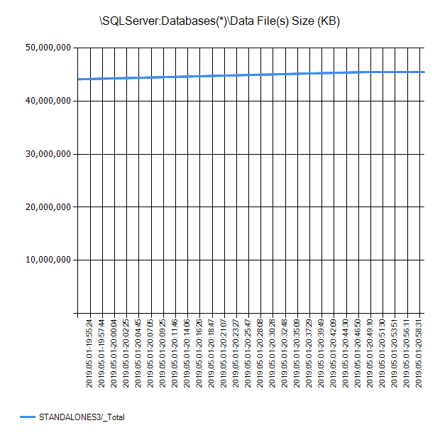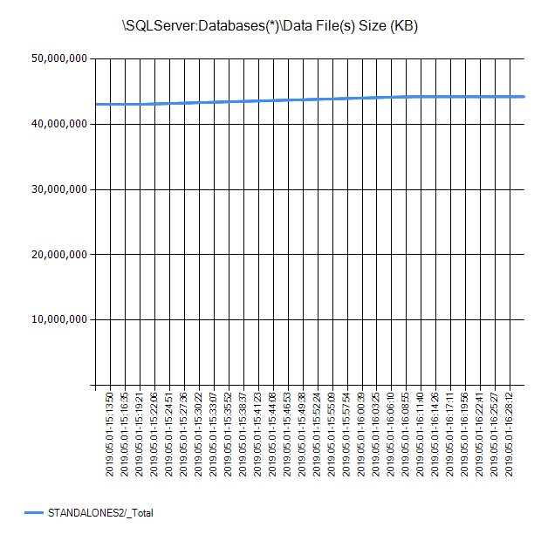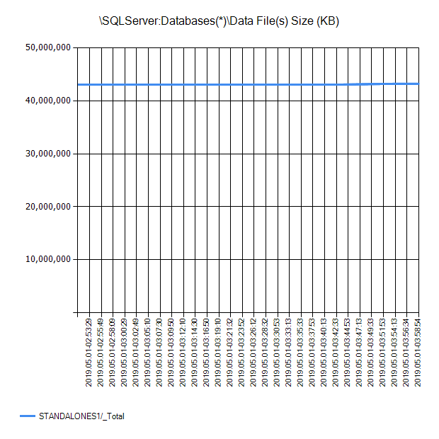

*StandAloneS3*

*StandAloneS4*

StandAloneS1

*StandAloneS2*

### SQLServer:Databases Log Bytes Flushed/sec

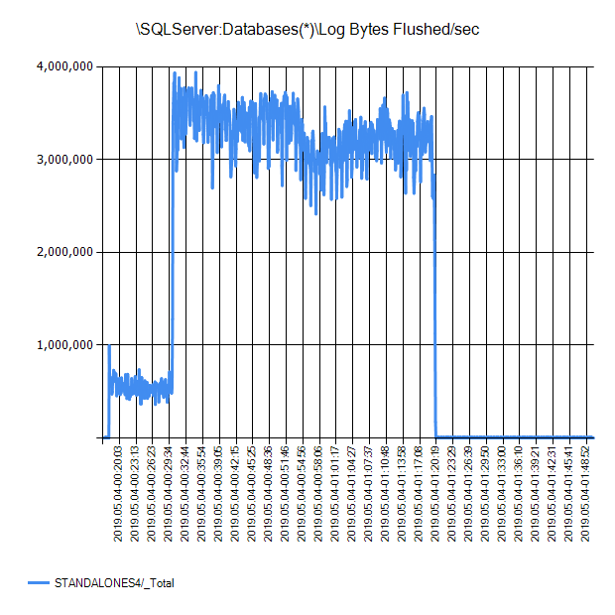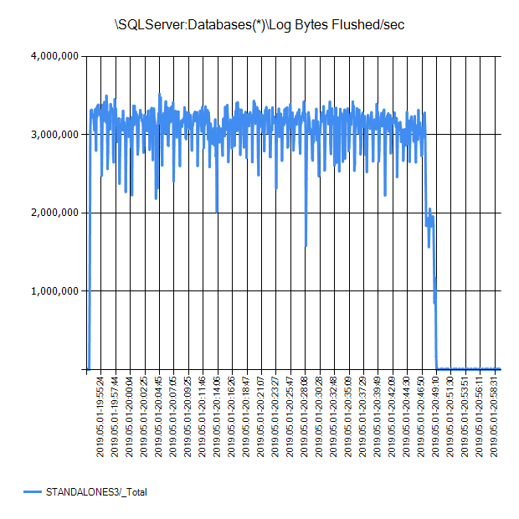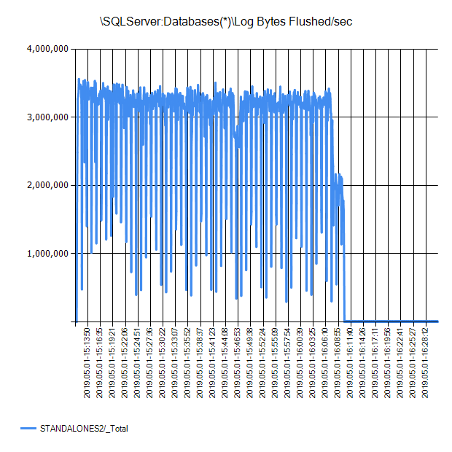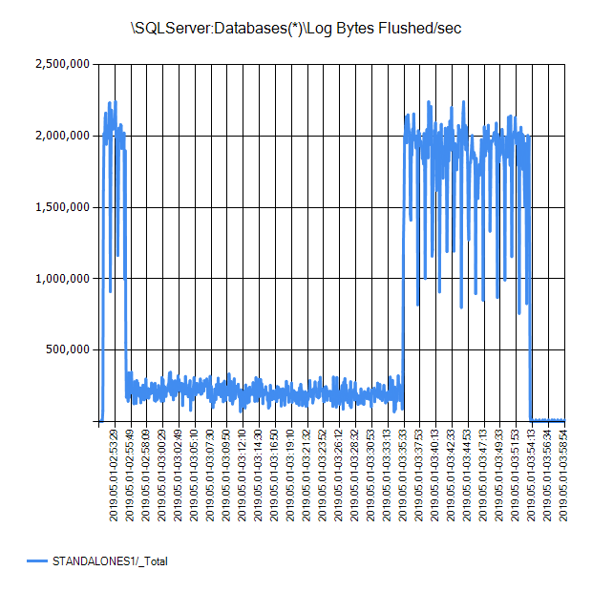

*StandAloneS4*

*StandAloneS3*

*StandAloneS2*

StandAloneS1

### SQLServer:Databases Log File(s) Used Size (KB)

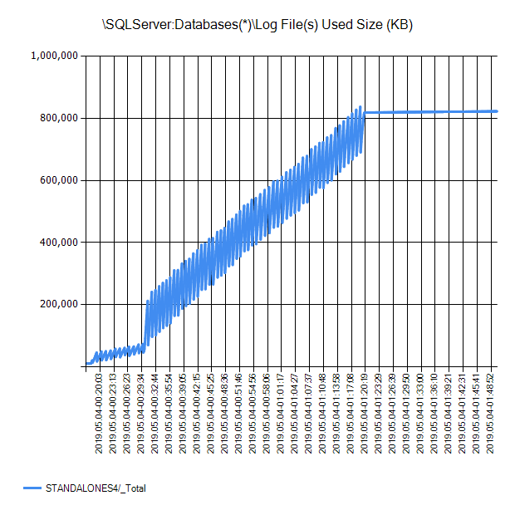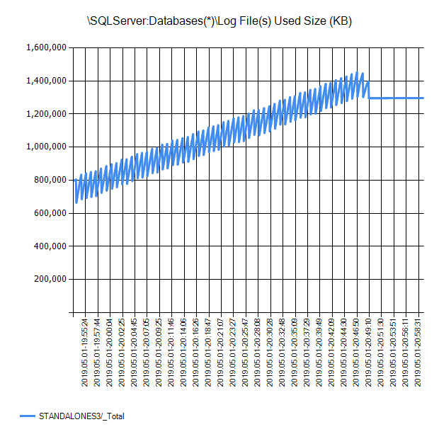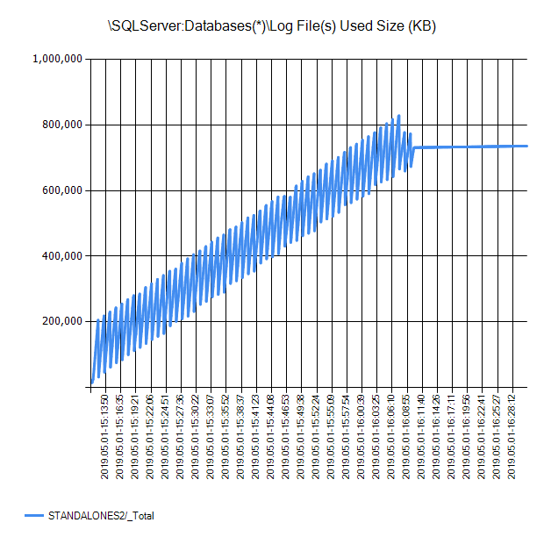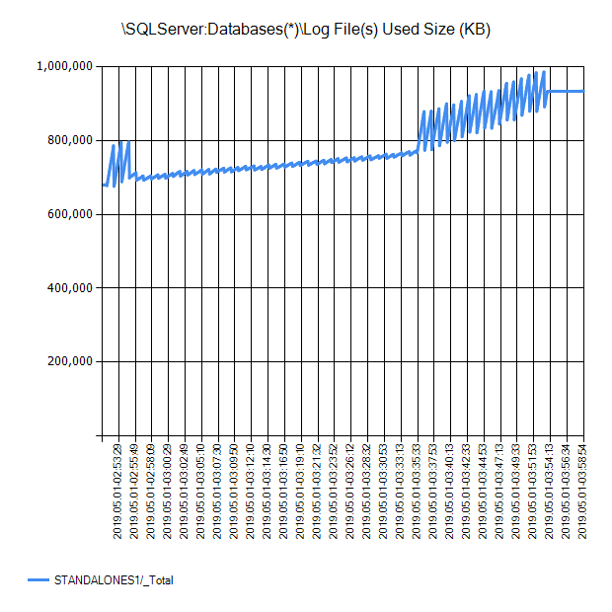

*StandAloneS4*

*StandAloneS3*

*StandAloneS2*

StandAloneS1

### SQLServer:Resource Pool Stats CPU usage %

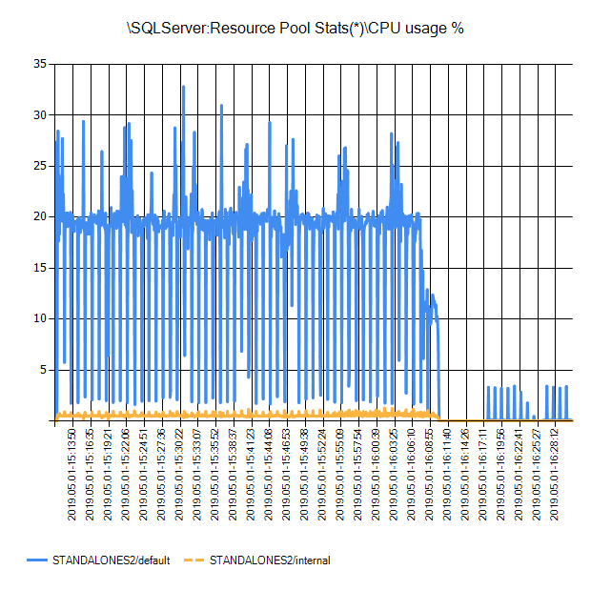

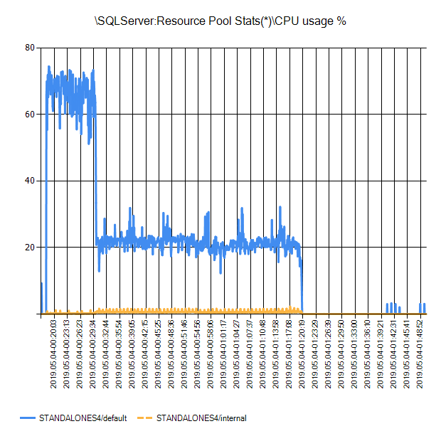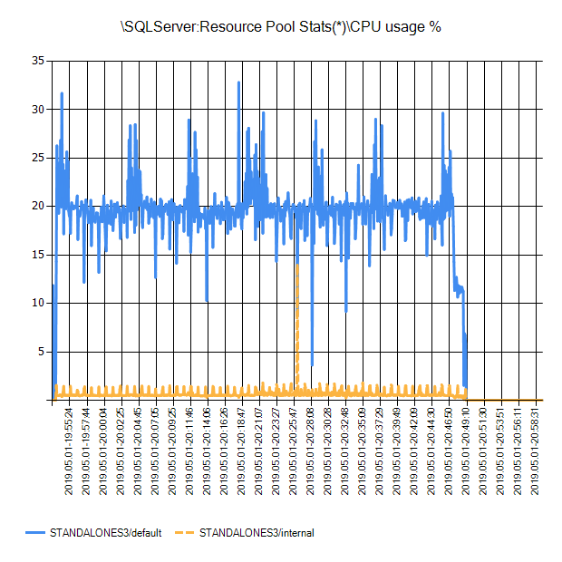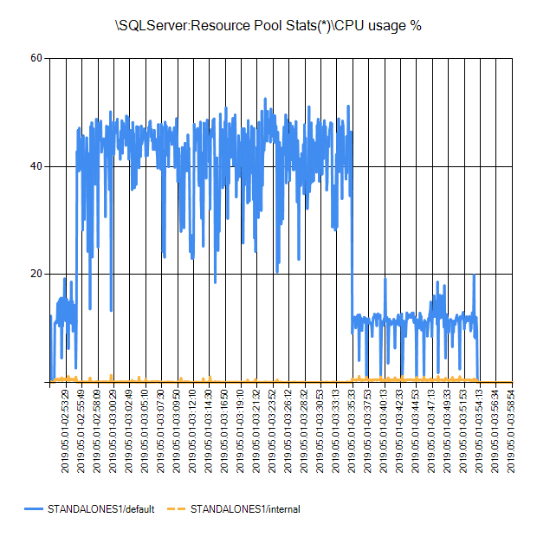

*StandAloneS4*

*StandAloneS3*

StandAloneS1

*StandAloneS2*

### SQLServer:Workload Group Stats CPU usage %

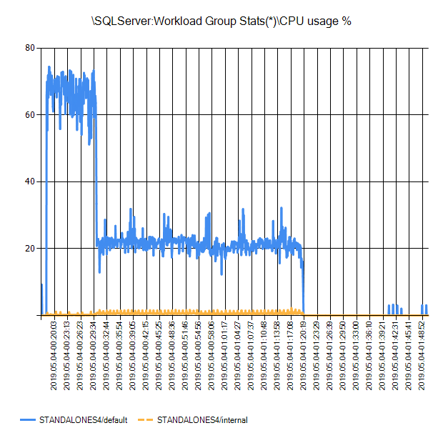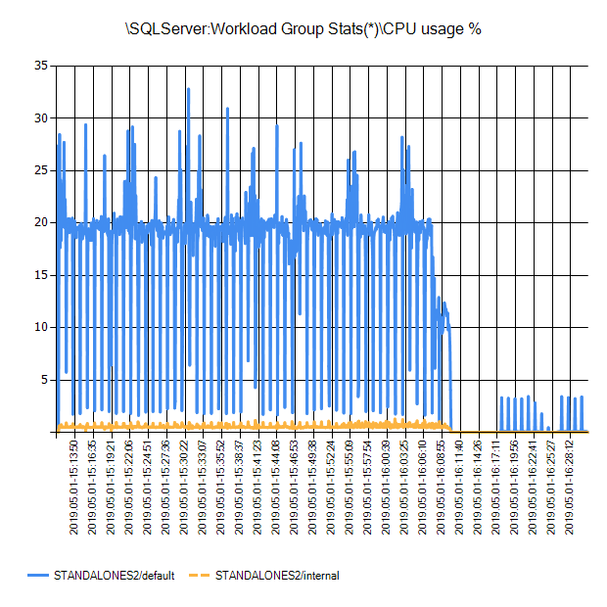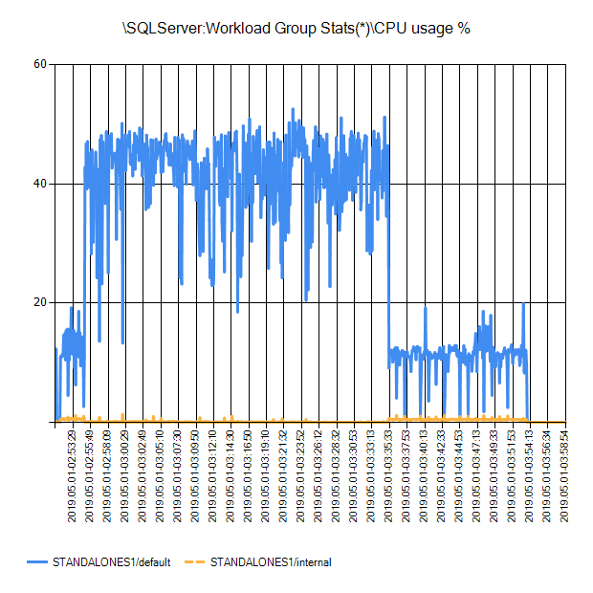

*StandAloneS4*

*StandAloneS2*

StandAloneS1

### \SQLServer:Workload Group Stats(*)\CPU usage %SQLServer:Workload Group Stats Requests completed/sec

*StandAloneS3*

### \SQLServer:Workload Group Stats(*)\Requests completed/sec

*StandAloneS4*

*StandAloneS3*

StandAloneS1

*StandAloneS2*

## SQL Nexus Results

### STANDALONES1

#### Bottleneck Analysis



#### Server Configuration



#### Database Configuration and Properties



#### IO Metrics



#### Perfmon Summary



#### Performance Overview



#### Top Unique Batches



#### Virtual File Stats



### STANDALONES2

#### Bottleneck Analysis



#### Server Configuration



#### Database Configuration and Properties



#### IO Metrics



#### Perfmon Summary



#### Performance Overview



#### Top Unique Batches



#### Virtual File Stats



### STANDALONES3

#### Bottleneck Analysis



#### Server Configuration



#### Database Configuration and Properties



#### IO Metrics



#### Perfmon Summary



#### Performance Overview



#### Top Unique Batches



#### Virtual File Stats



### STANDALONES4

#### Bottleneck Analysis



#### Server Configuration



#### Database Configuration and Properties



#### IO Metrics



#### Perfmon Summary



#### Performance Overview



#### Top Unique Batches



#### Virtual File Stats



# Appendix

## Default Installation and Configuration

### SQL Server 2008 R2 Stand-alone servers

#### Disk Configuration

1. Initialize Logical Disk as Master Boot Record (MBR)

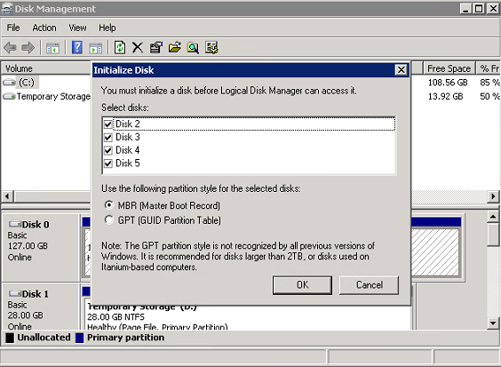

1. Format Volume as New Simple…

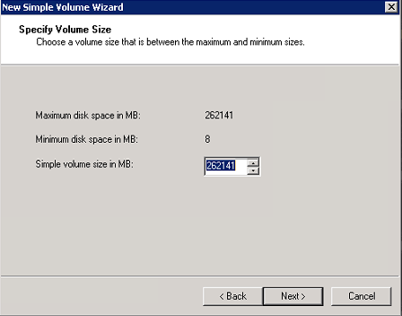

1. Assign drive letter

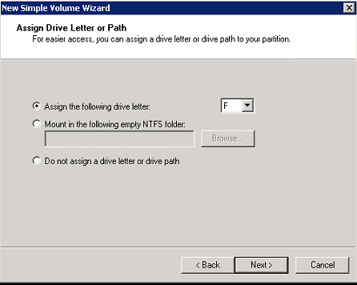

1. Format as:
   1. File system: NTFS
   2. Allocation Unit Size: 64K
   3. Volume Label: SQL*
   4. check box Perform a quick format

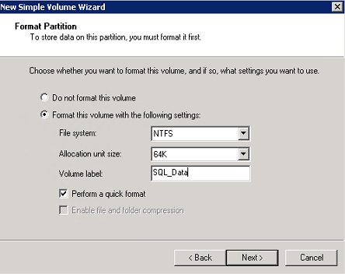

#### SQL Server Configuration

1. Execute *setup* and select OK on the .NET Framework Core enablement dialog

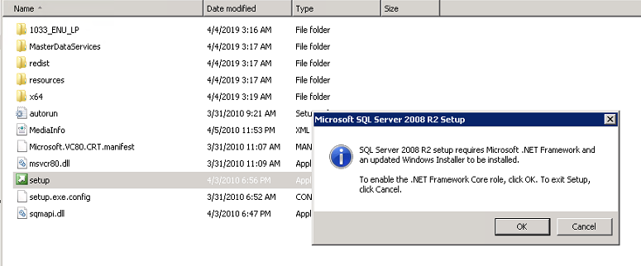

1. From the SQL Server Installation Center, select *Installation -> New Installation or add features to an existing installation.*

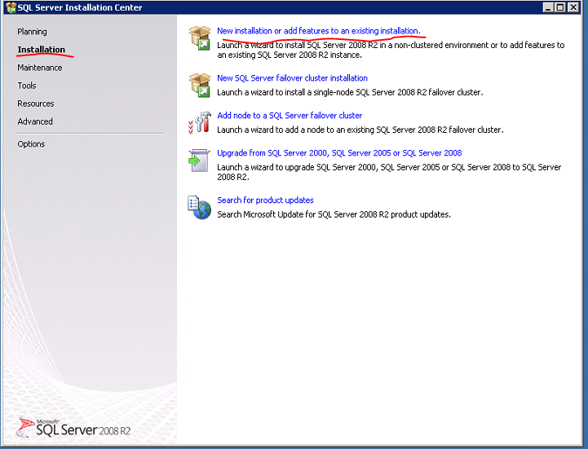

1. Click OK on *Setup Support Rules*

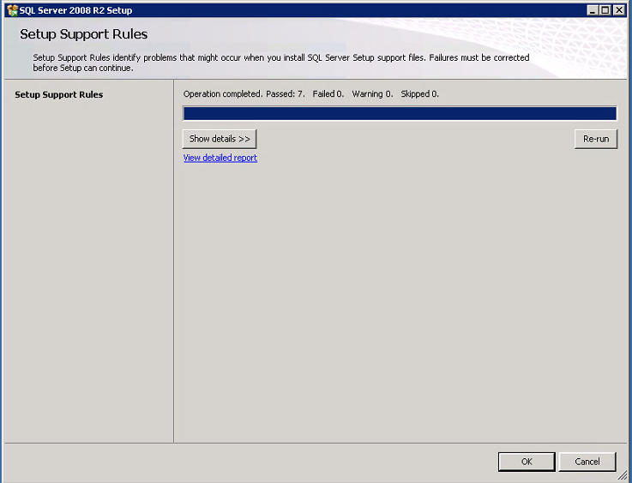

1. Click Next on *Product Key*

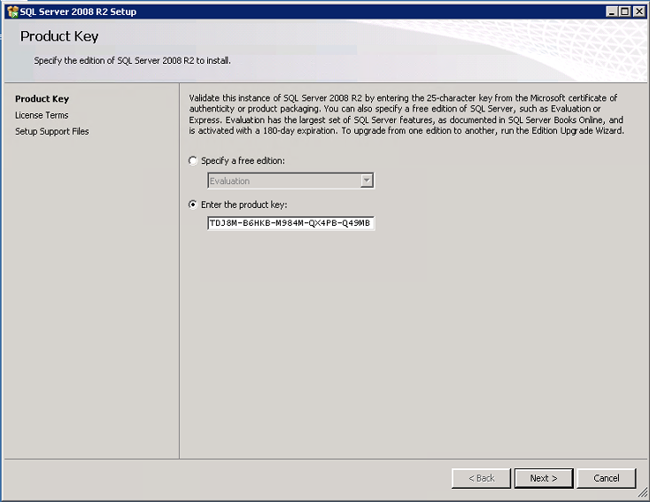

1. Check the *I accept the license terms* checkbox

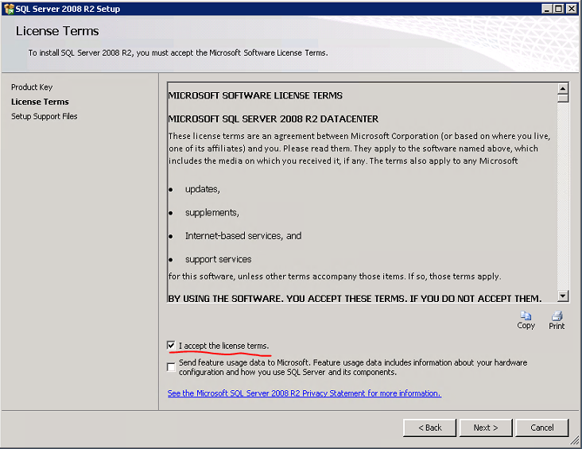

1. Click Install on *Setup Support Files*

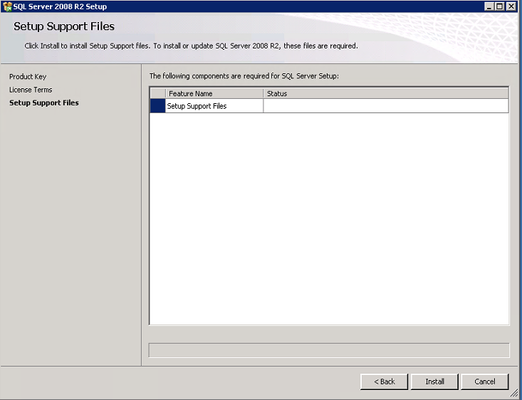

1. Review *Setup Support Rules* installation; then select Next

*Note: Windows Firewall warning may be ignored

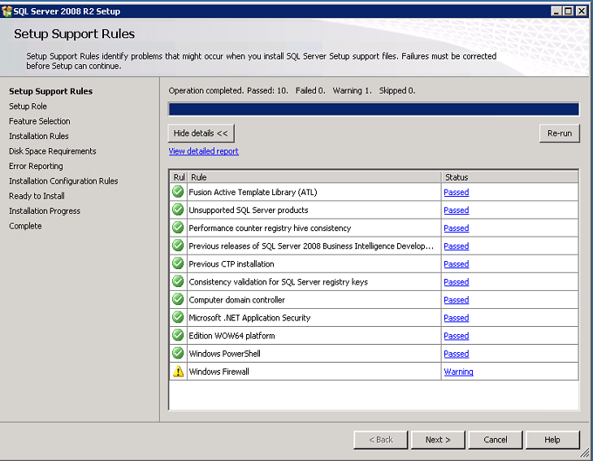

1. Chose *SQL Server Feature Installation* radio button; click Next

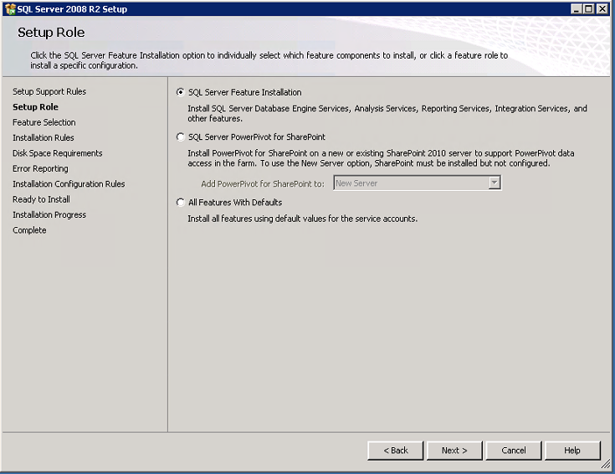

1. Chose the features to install
   1. Database Engine Services
   2. Management Tools – Basic and Management Tools – Complete
   3. Leave the default values for Shared feature directory file locations
      1. C:\Program Files\Microsoft SQL Server\
      2. C:\Program Files (x86)\Microsoft SQL Server\

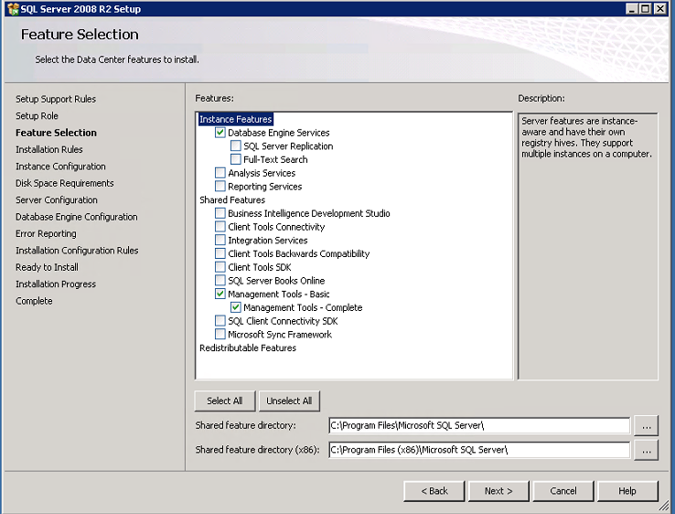

1. Review Installation Rules validation; click Next

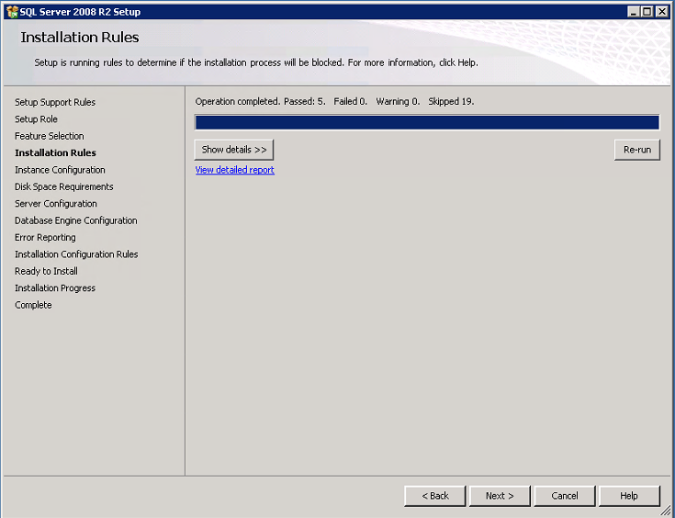

1. Chose *Default Instance*
   1. Instance ID: MSSQLSERVER
   2. Instance root directory: C:\Program Files\Microsoft SQL Server\

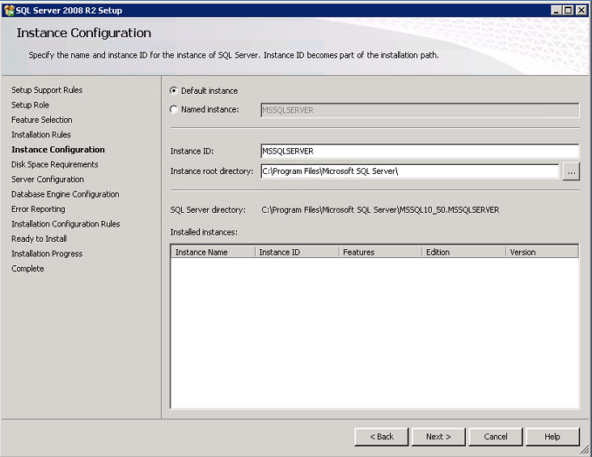

1. Review *Disk Requirements*, Click Next

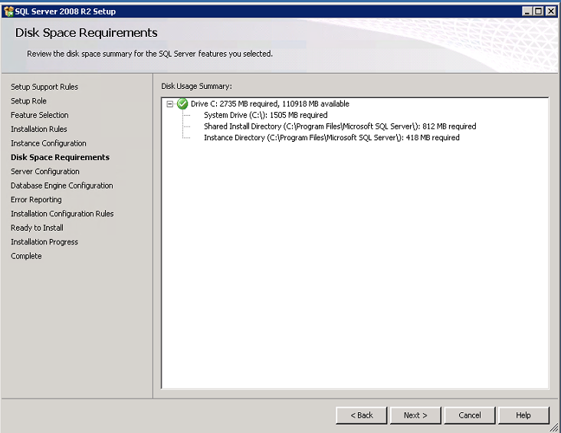

1. Configure *Service Accounts*

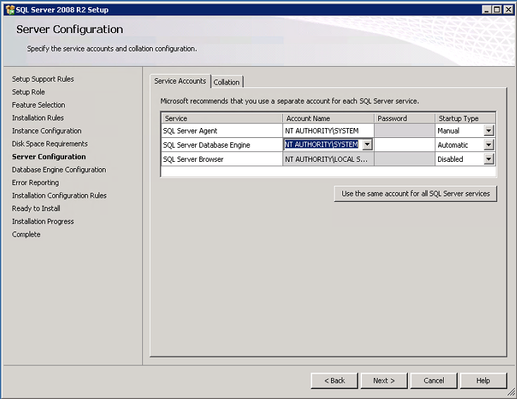

1. Leave *Collation* default

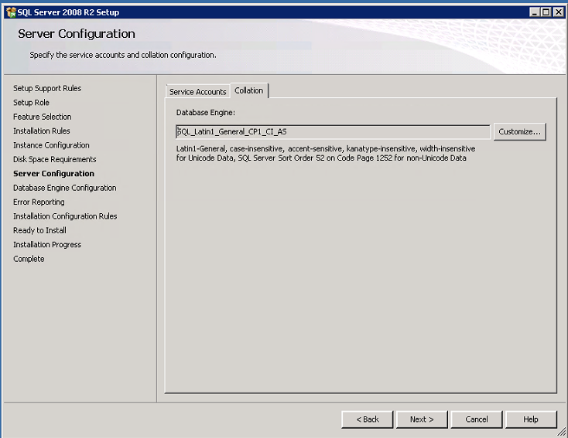

1. Configure *authentication mode and administrators*

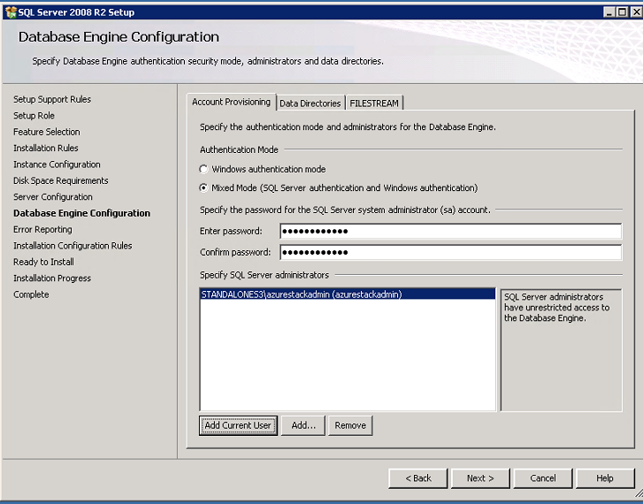

1. Configure *Data Directories*

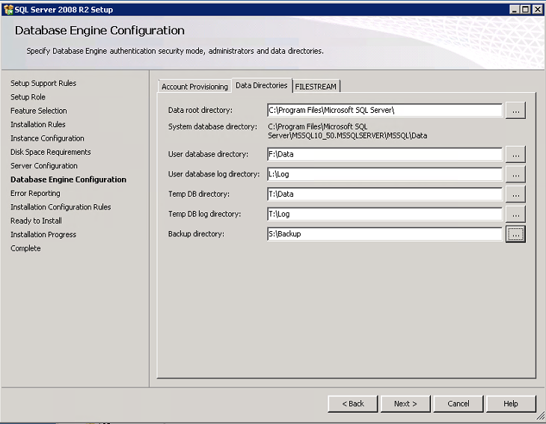

1. Click Next on *Error Reporting*

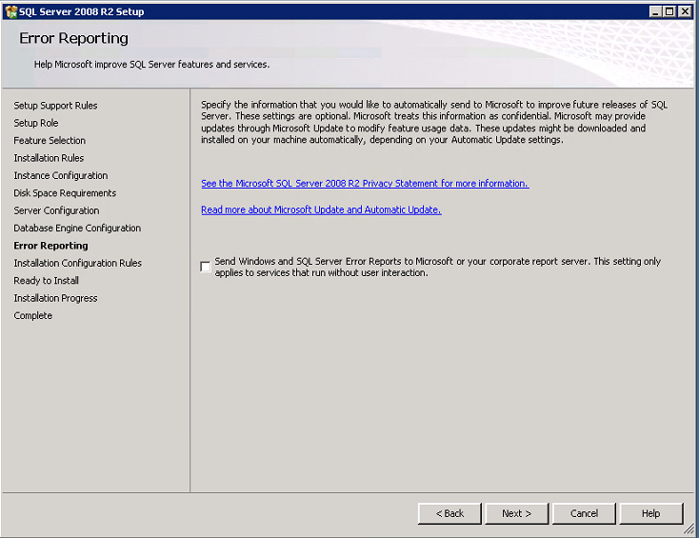

1. Review *Installation Configuration Rules* validation report; Click Next

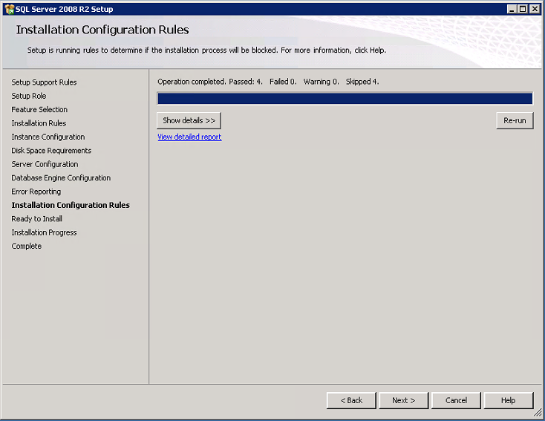

1. Review *Ready to Install; Click Install*

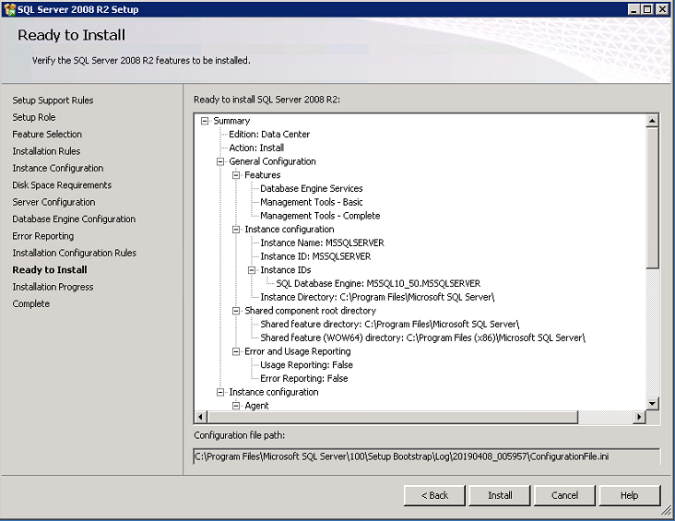

1. Monitor *Installation Progress*

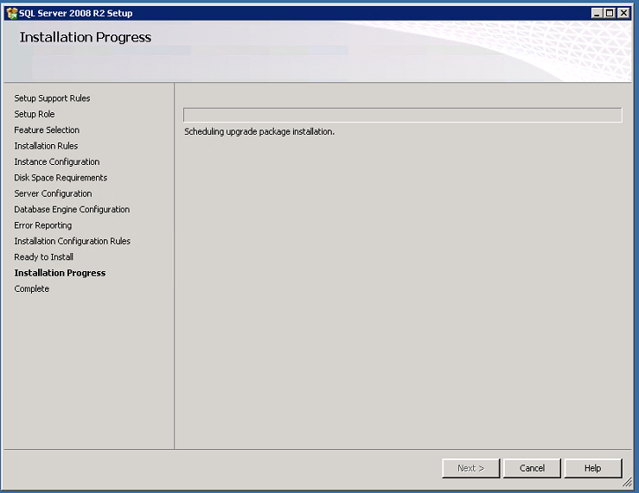

1. Completion, Close installer

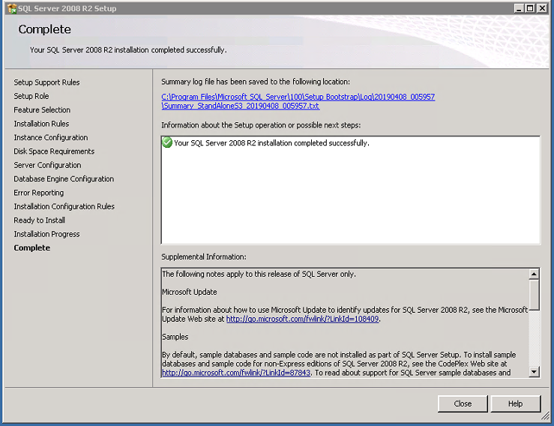

#### Post-Installation Configuration

1. Configure SQL Server Memory
2. Configure SQL Server MaxDOP (Max Degrees of Parallelism)
3. Configure SQL Server temp database files

<https://microsofteur.sharepoint.com/teams/AzStackSQLMigration/Shared%20Documents/General/Standard%20Configure%20-%20SQL%20Instance%20Properties.zip>